**CRM Application for Jewel Management**

**College Name : AVP College of Arts and Science**

**College Code :**

**TEAM ID :**

**TEAM MEMBERS:**

**Team Leader Name: M.Kanishka**

**Email Id:** [**kanishkamagesh352@gmail.com**](mailto:kanishkamagesh352@gmail.com)

**Team Member1: R. Subashini**

**Email Id:** [**subhashinirajendran24@gmail.com**](mailto:subhashinirajendran24@gmail.com)

**Team Member2: V.S. Amirthasri**

**Email Id:** [**amirthasriselvaraj75@gmail.com**](mailto:amirthasriselvaraj75@gmail.com)

**Team Member3: R. Padmapriya**

**Email Id:** [**padmapriyakrajendran@gmail.com**](mailto:padmapriyakrajendran@gmail.com)

**PROJECT OVERVIEW**

**A CRM application for a jewelry management project aims to enhance customer relationships, streamline operations, and boost revenue by centralizing customer data, personalizing communication, optimizing inventory, and providing actionable insights. Key purposes include tracking customer preferences, managing sales pipelines, improving customer service, and enabling targeted marketing campaigns tailored to the unique needs of the jewelry industry**

**PURPOSE**

* **Personalized Customer Engagement**
* **Sales & Lead Management**
* **Streamlined Operations**
* **Improved Customer Service**
* **Data-Driven Business Insights**
* **Inventory an Stock Optimization**

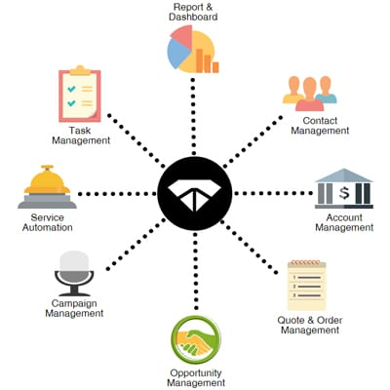

**SIGNING IN DEVELOPER ACCOUNT**

* Creating a developer account in Salesforce

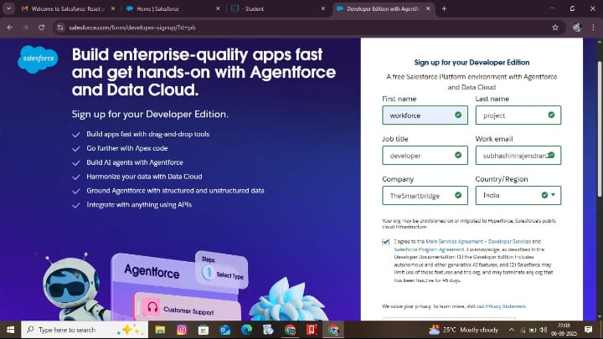

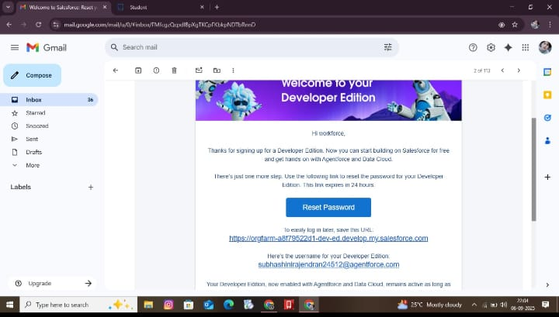

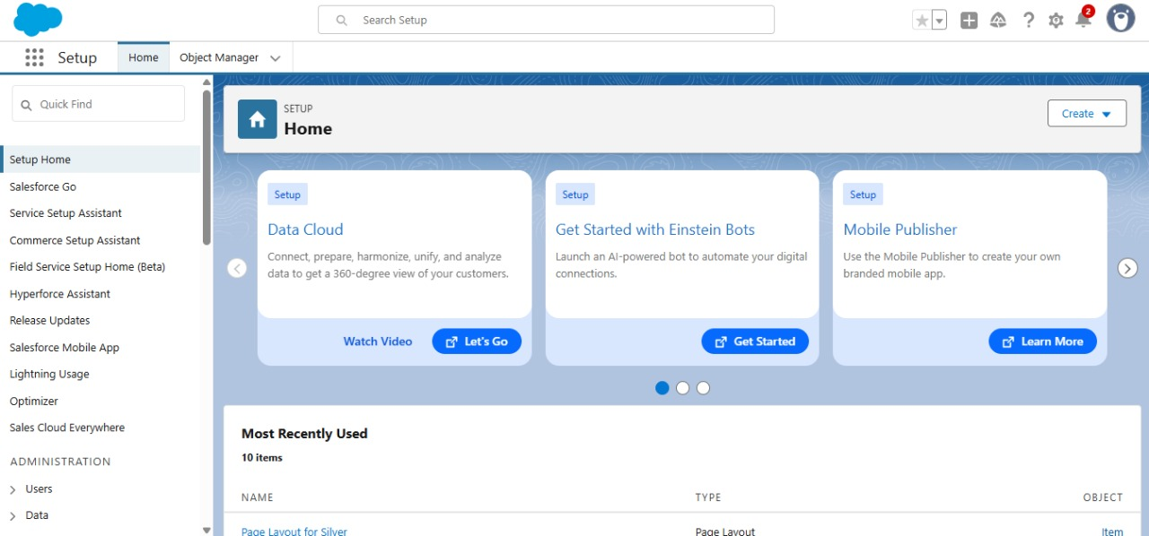

**OBJECTS**

**To create a jewel customer object**

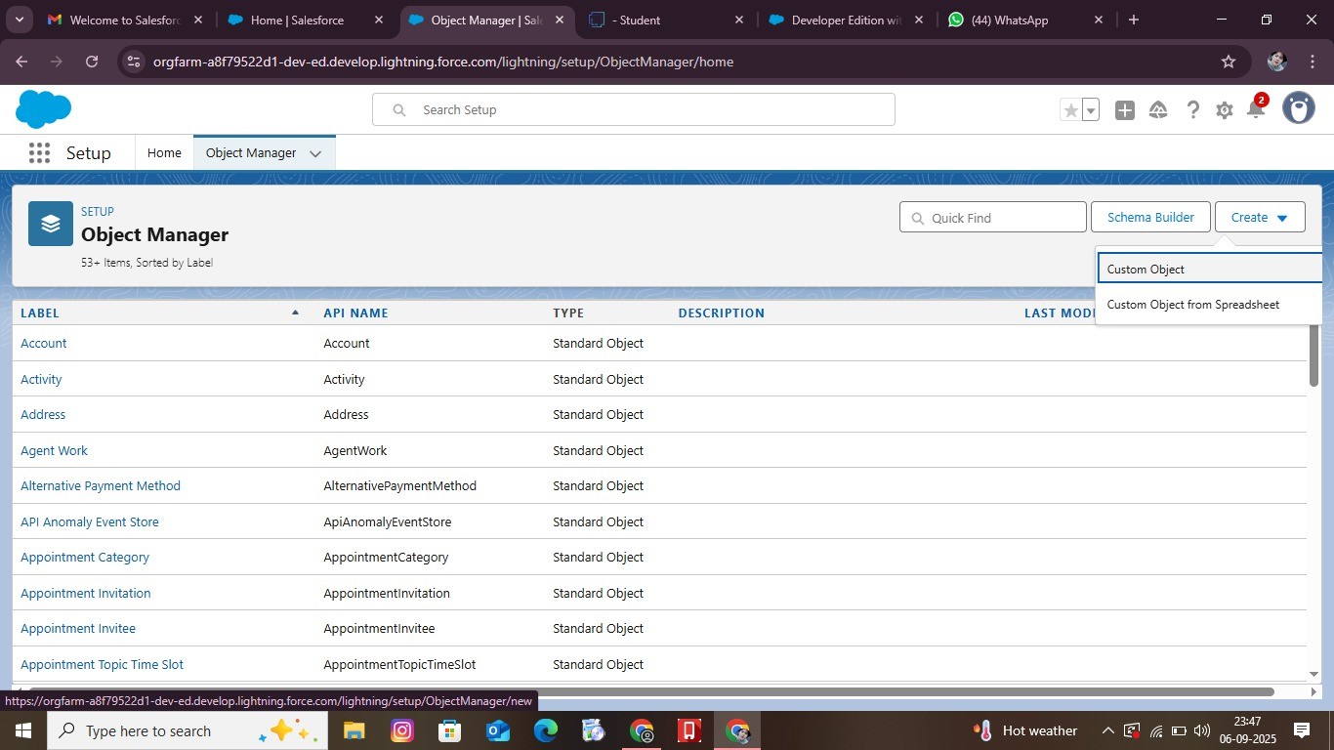

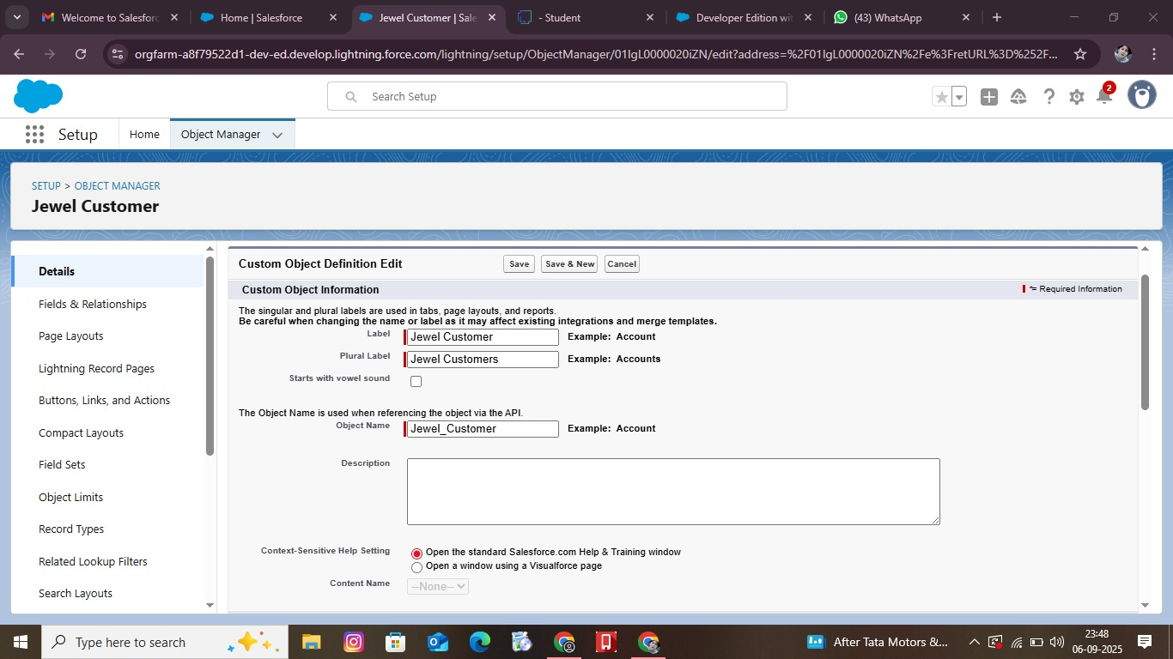

**Creating an Item object**

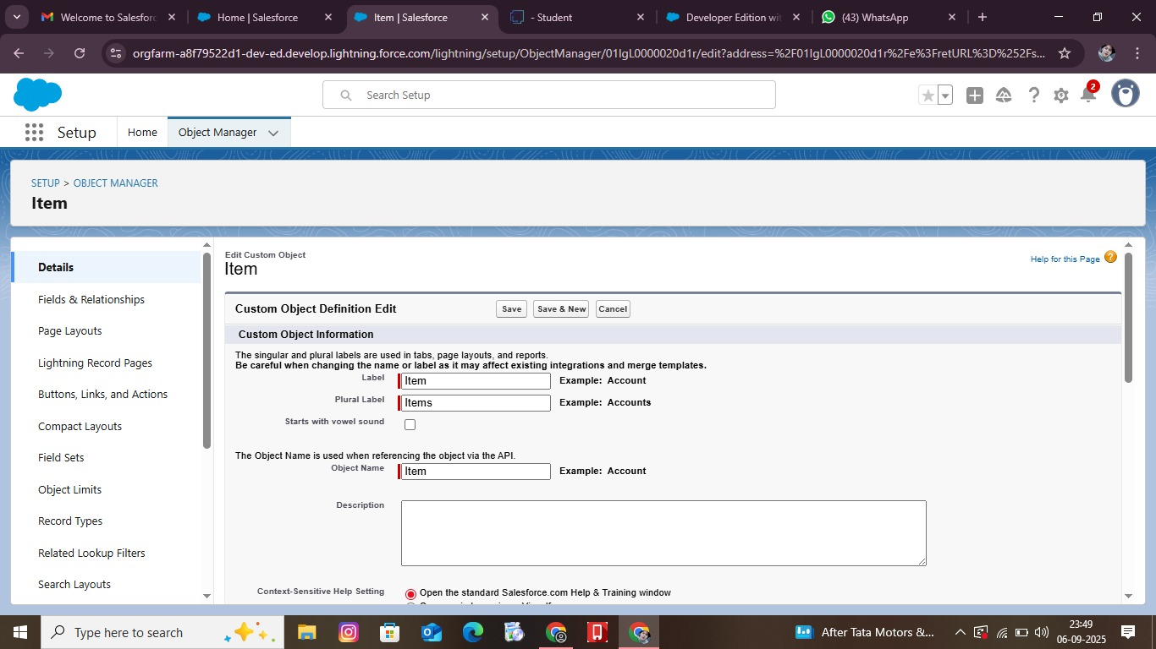

**Creating a Custom Tab**

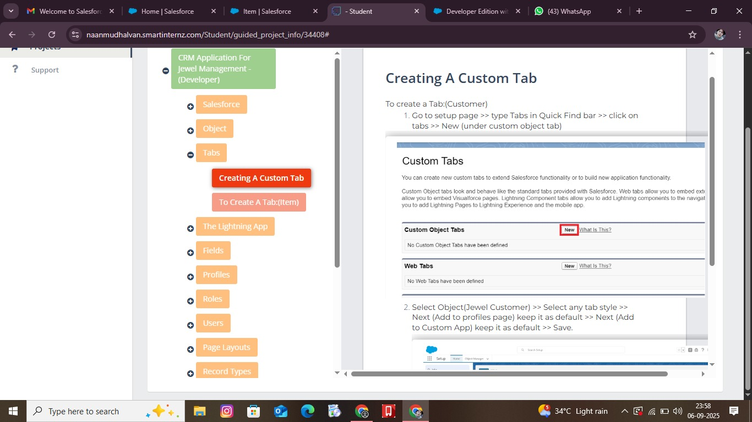

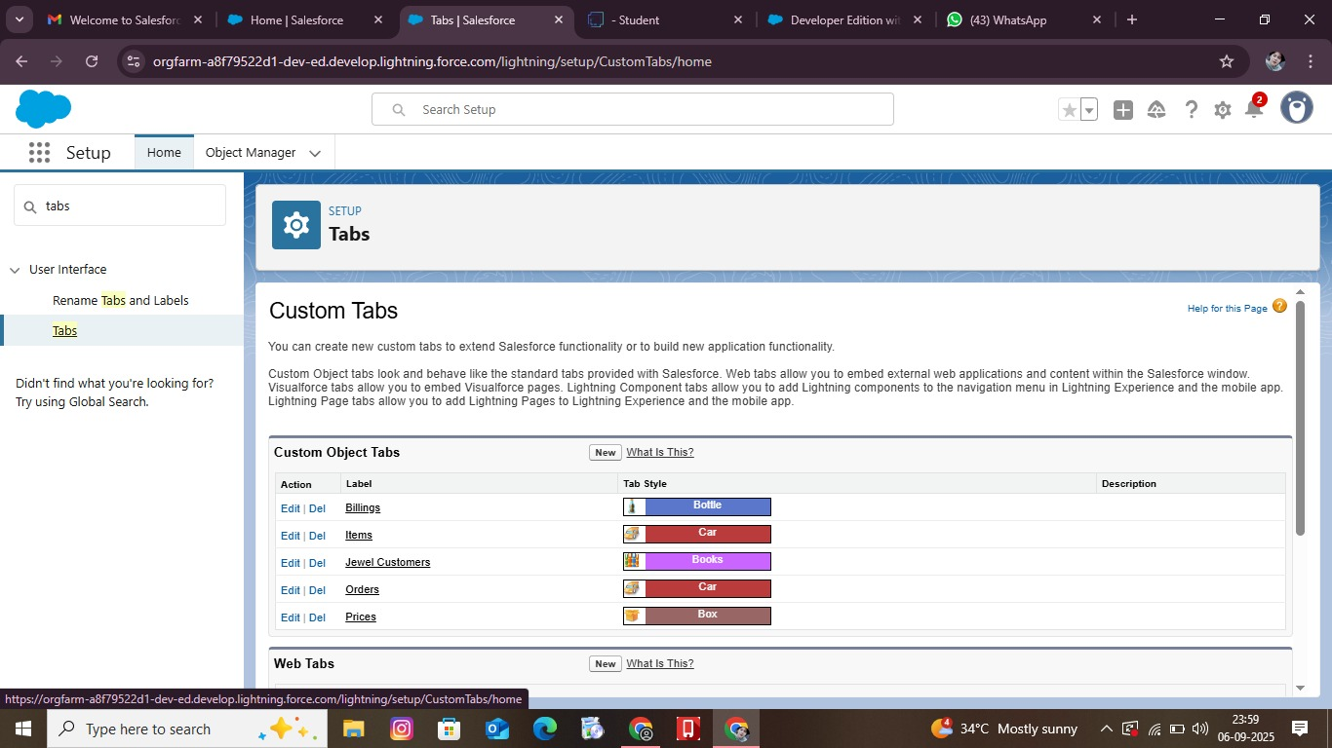

**LIGHTNING APP**

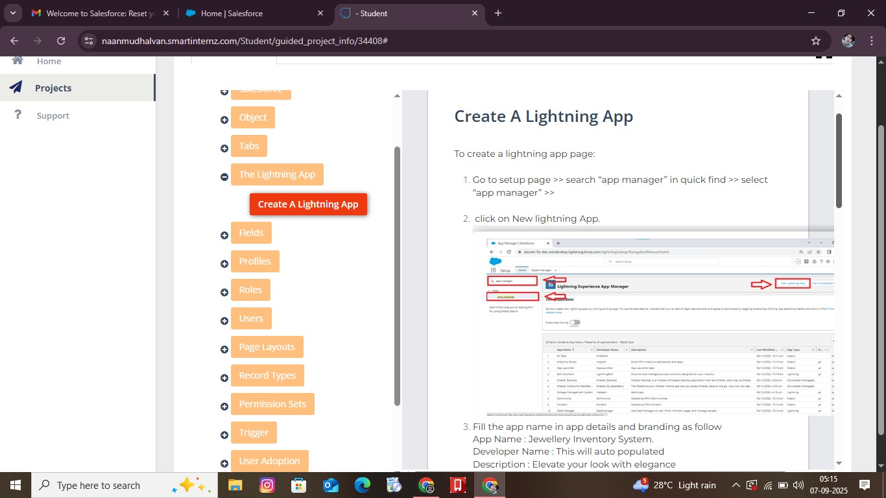

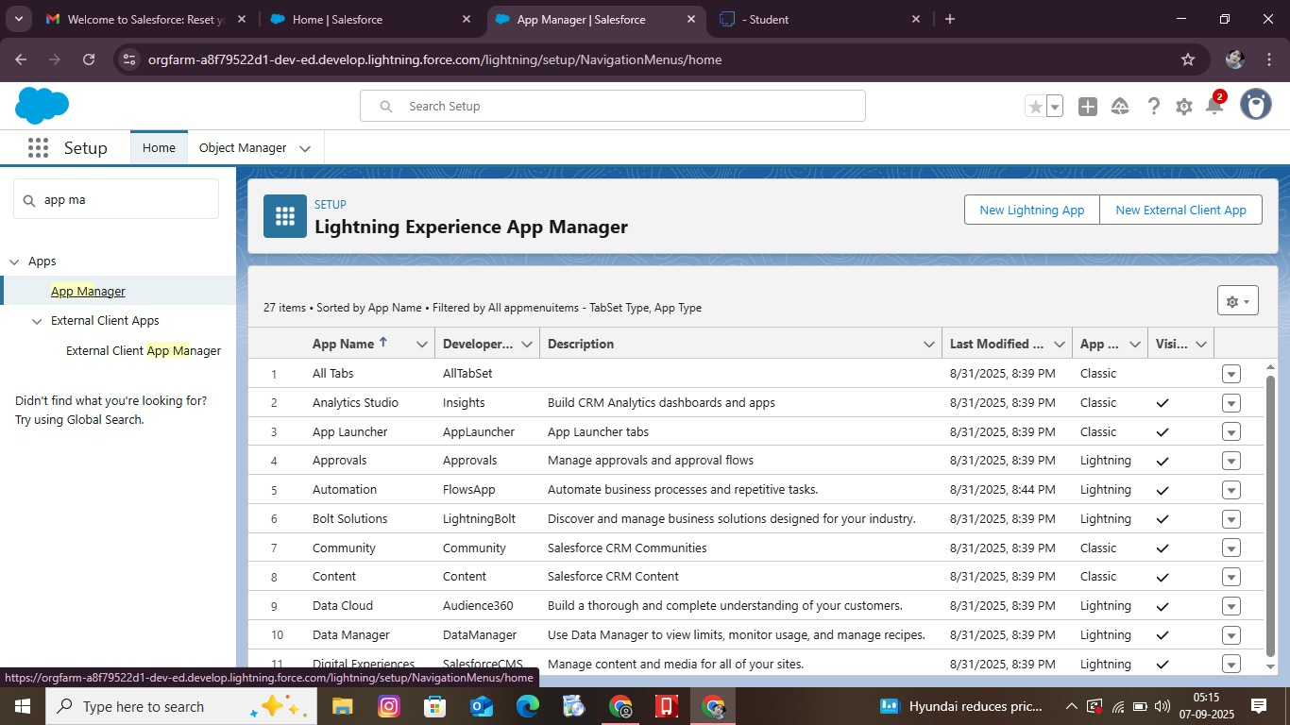

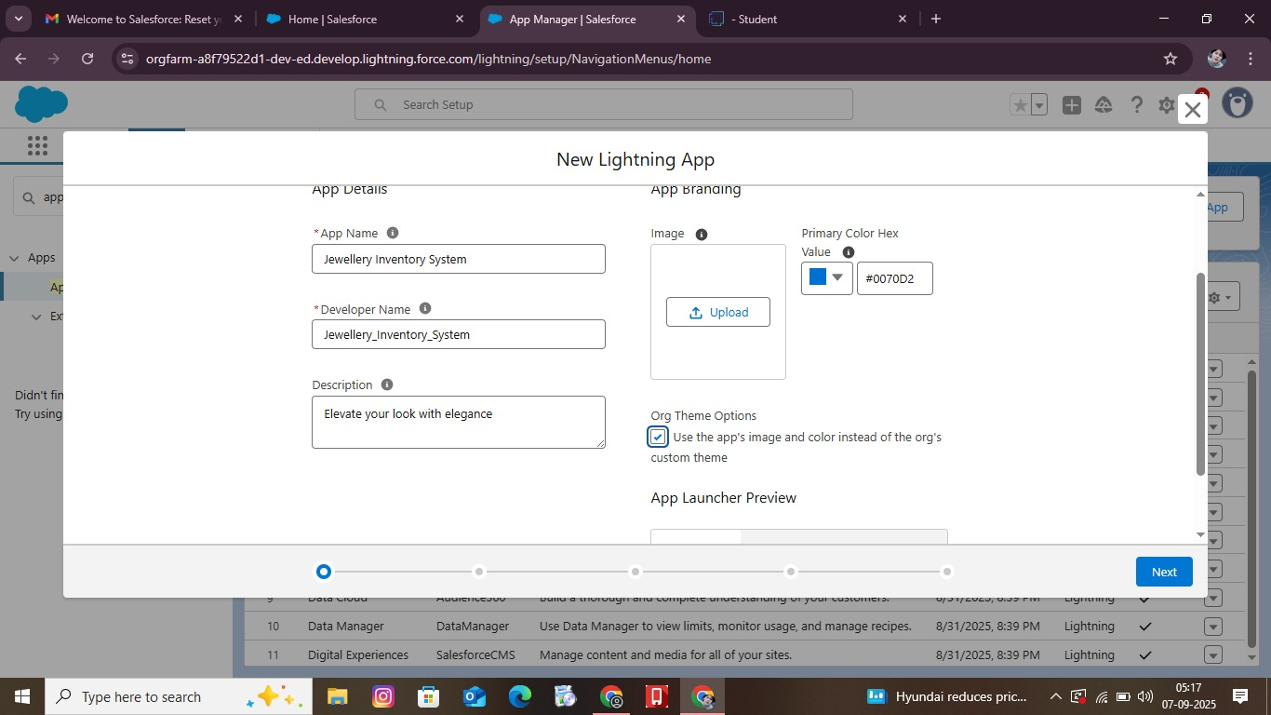

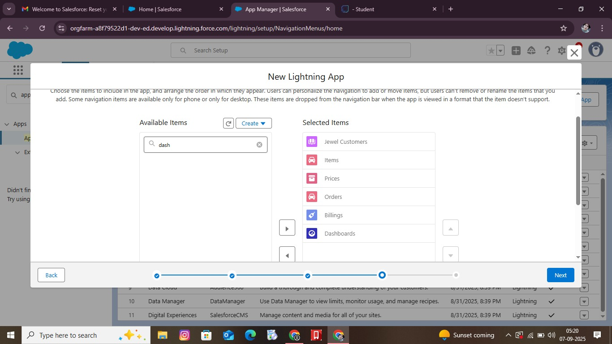

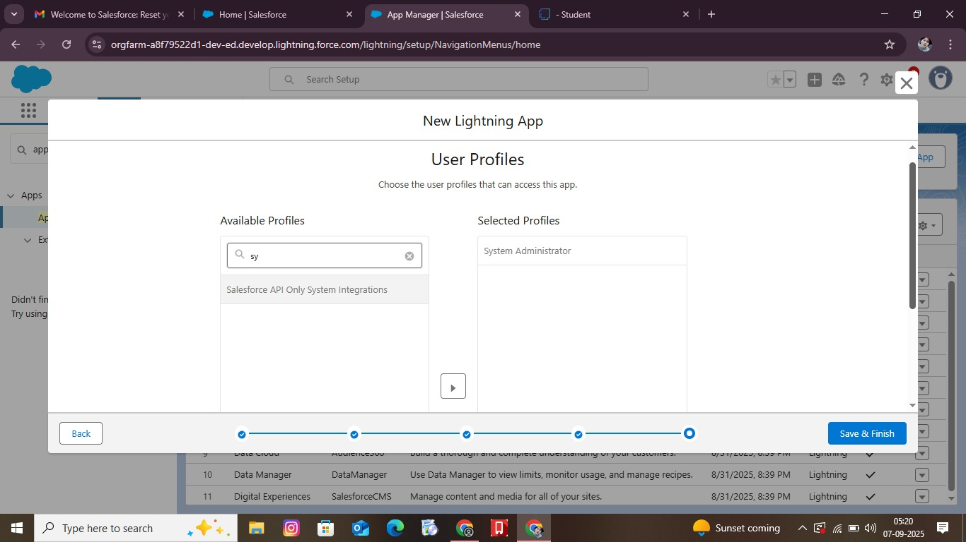

**FIELDS**

**Lookup Relationship**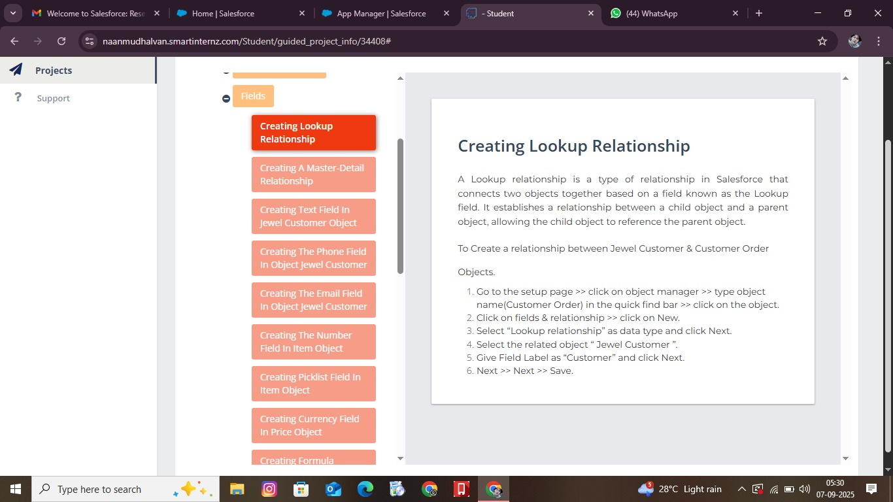

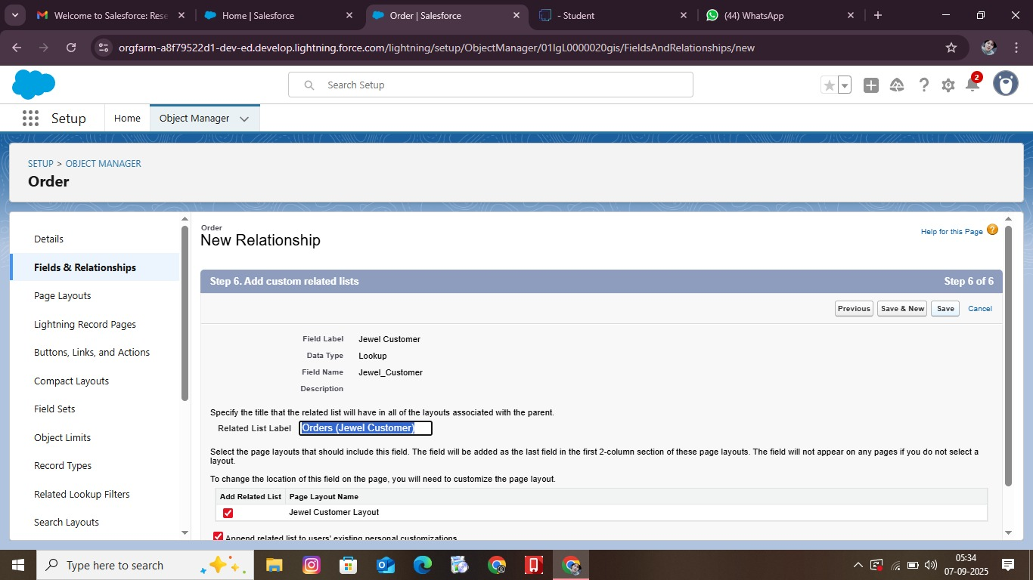

**Creating text fields in jewel customer object**

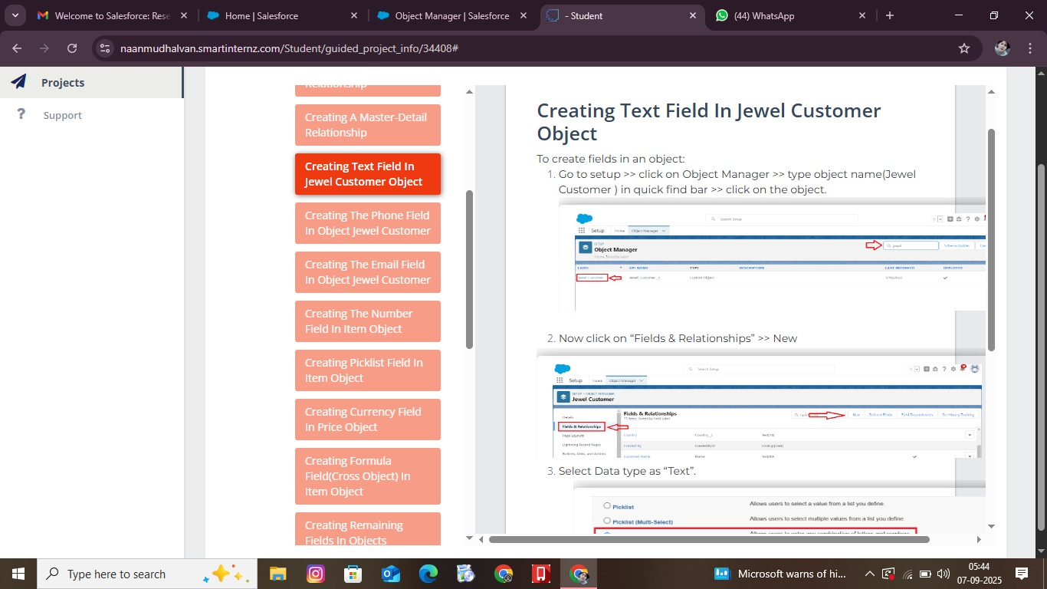

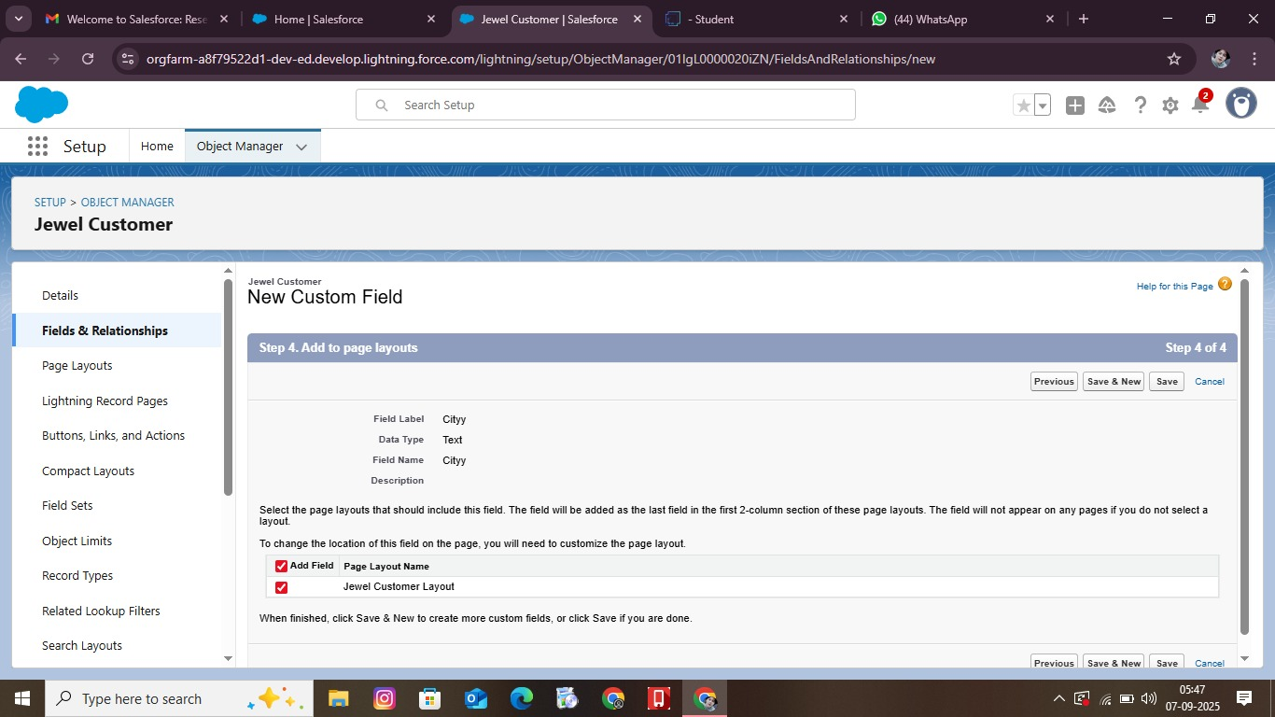

**Creating the email fields in jewel customer**

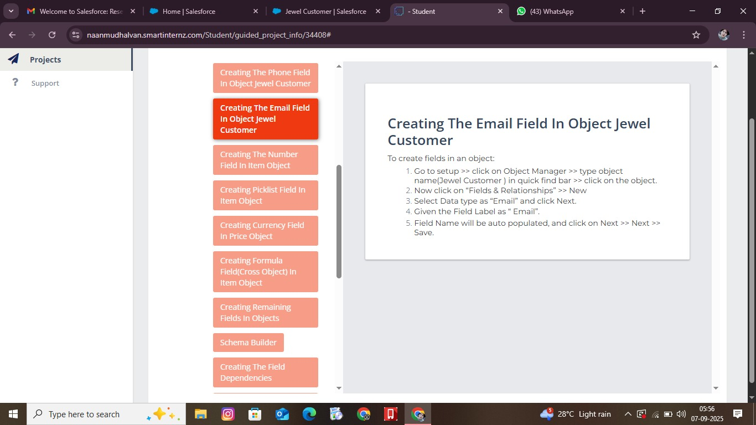

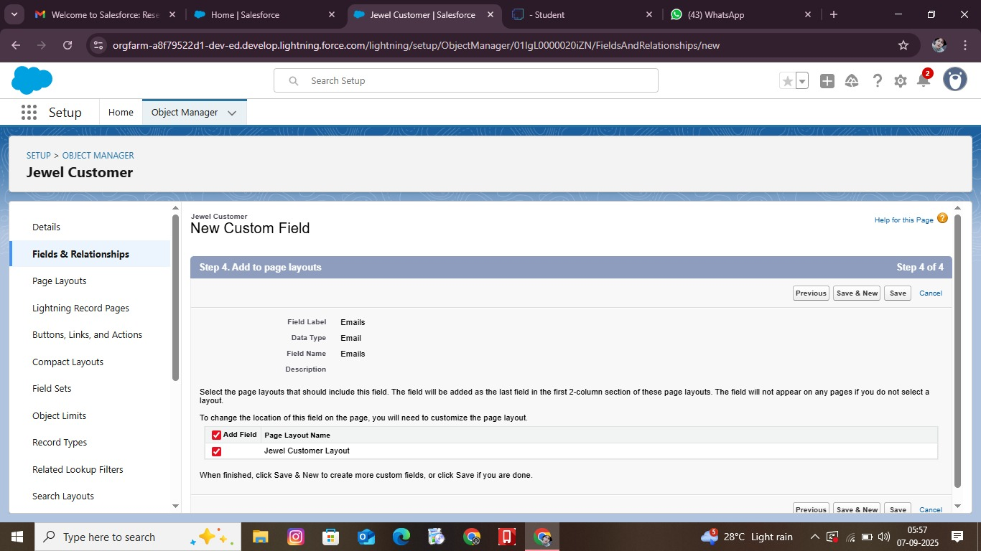

**Creating the number fields in Item objects**

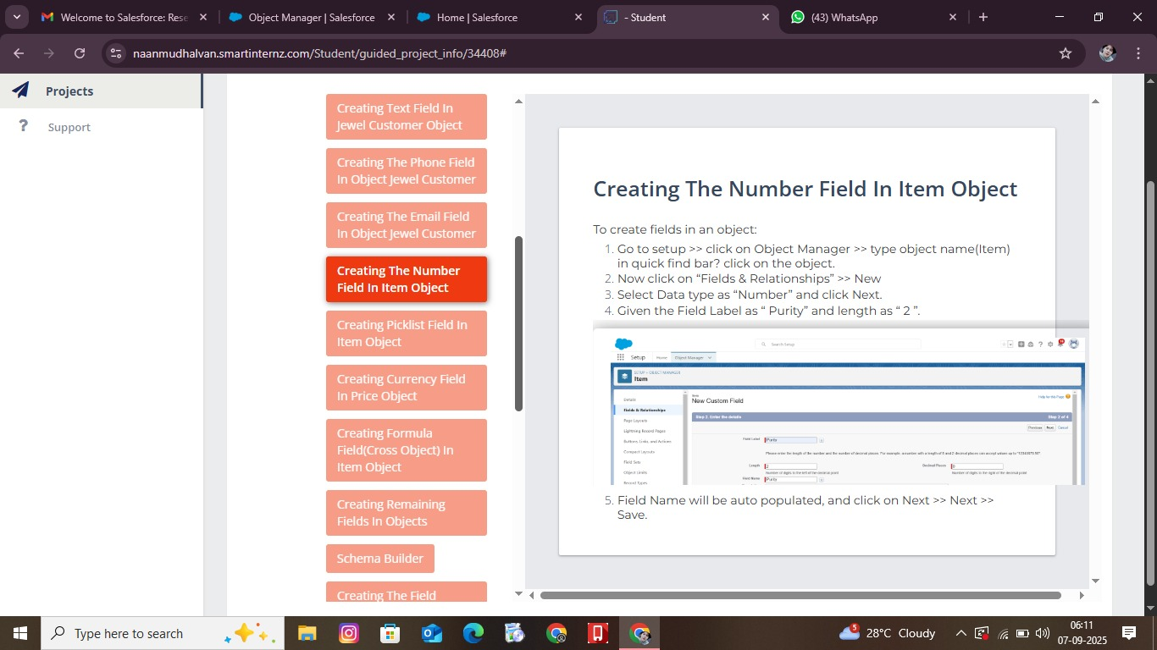

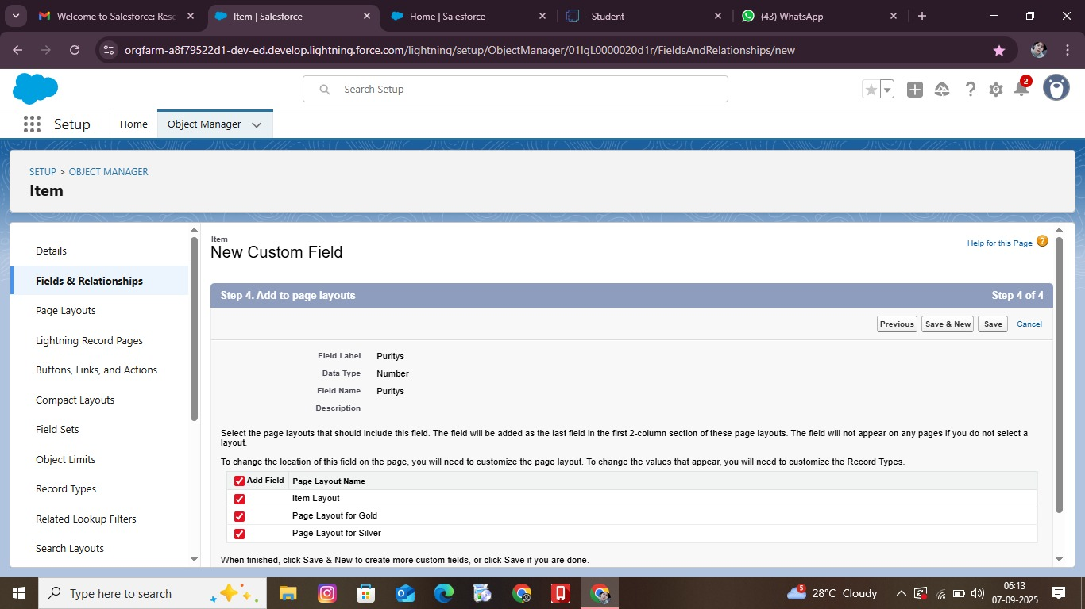

**Creating remaining fields in object**

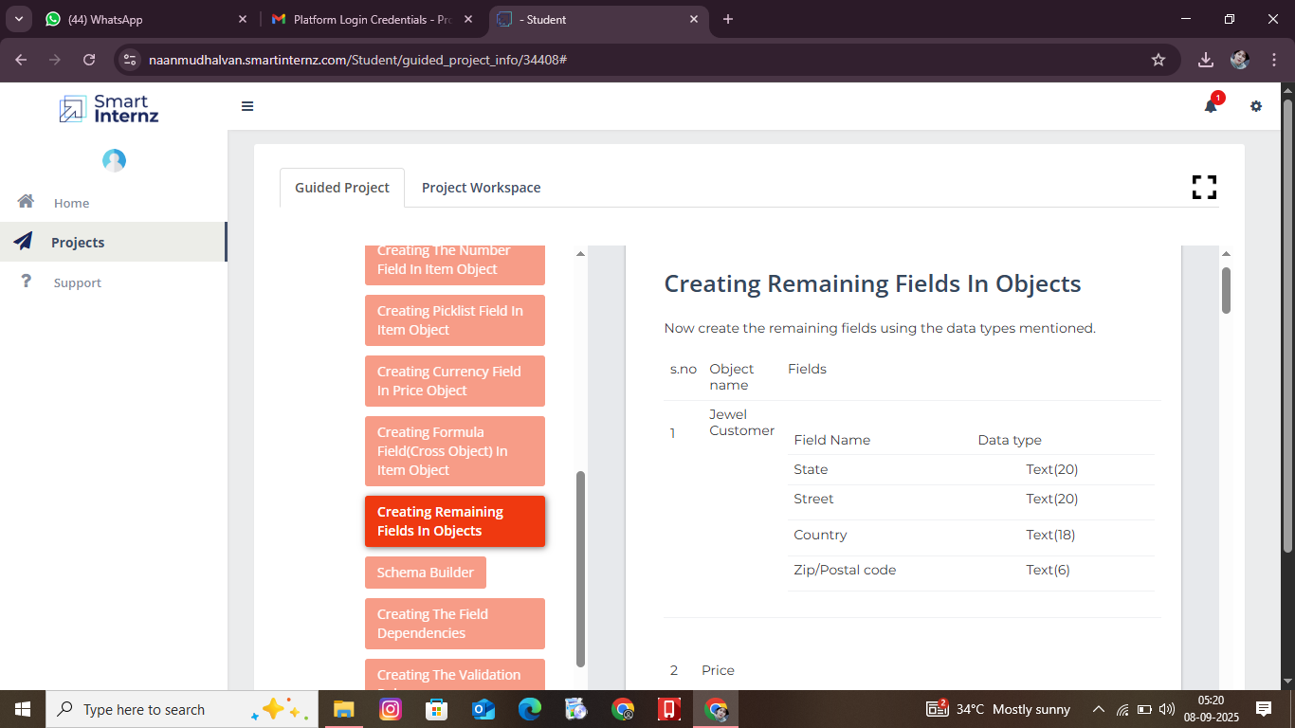

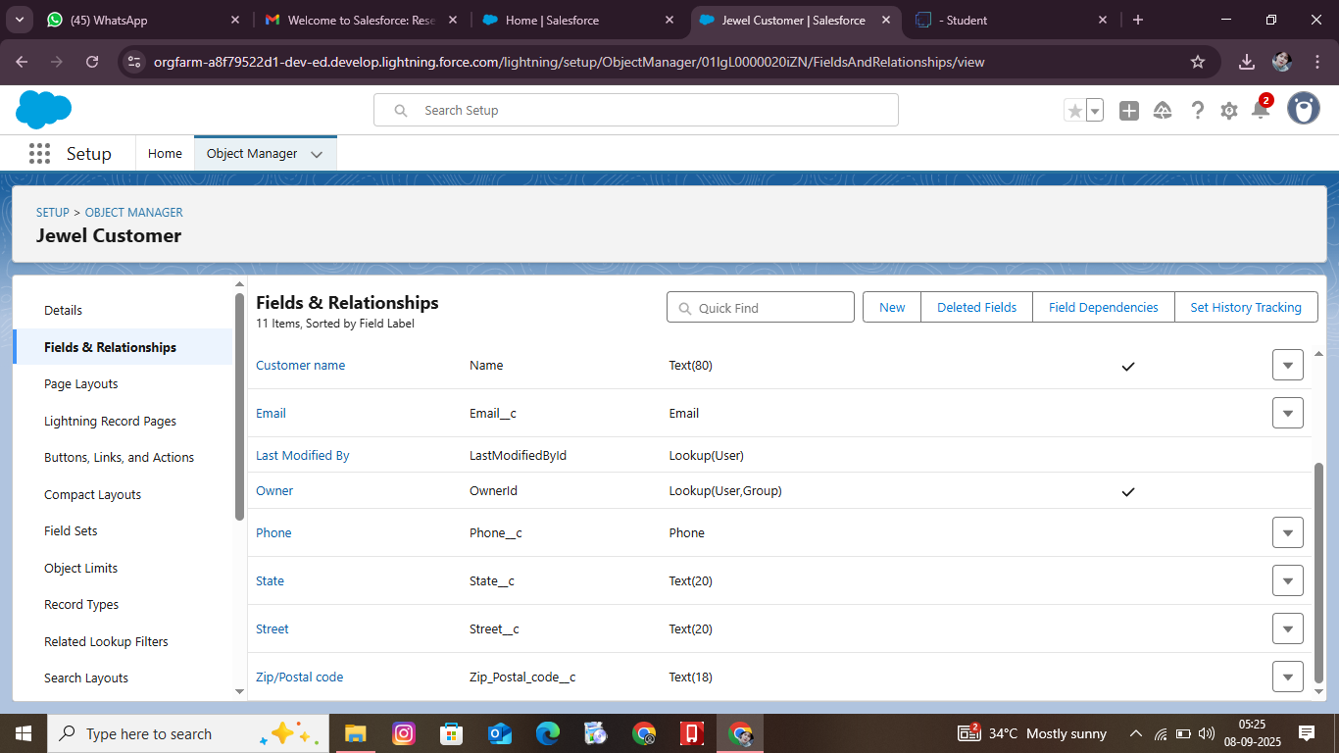

**PROFILE**

**Gold Smith Profile**

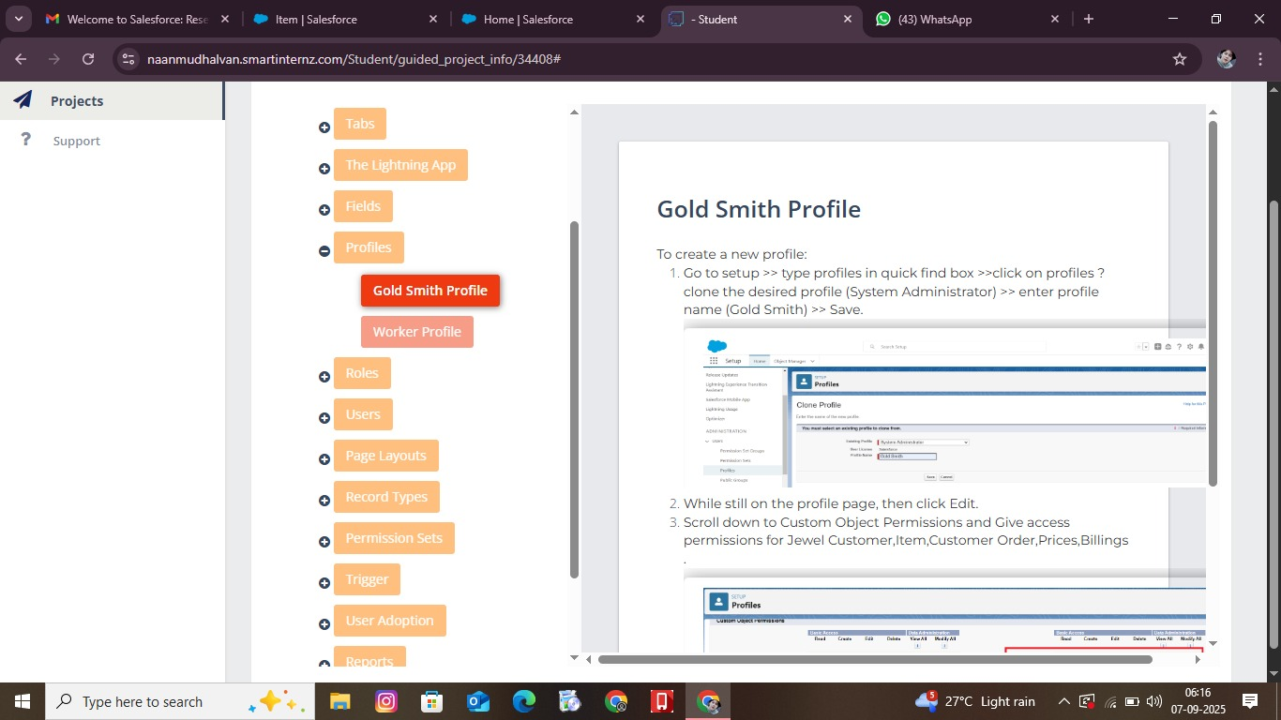

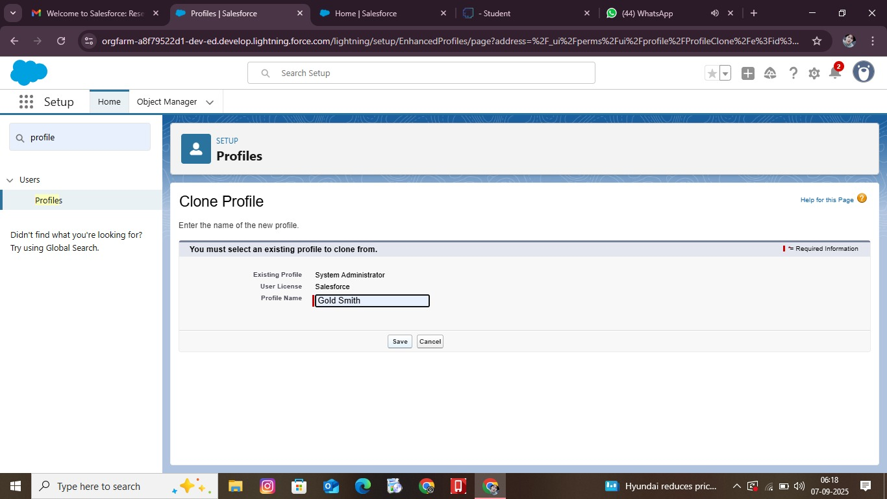

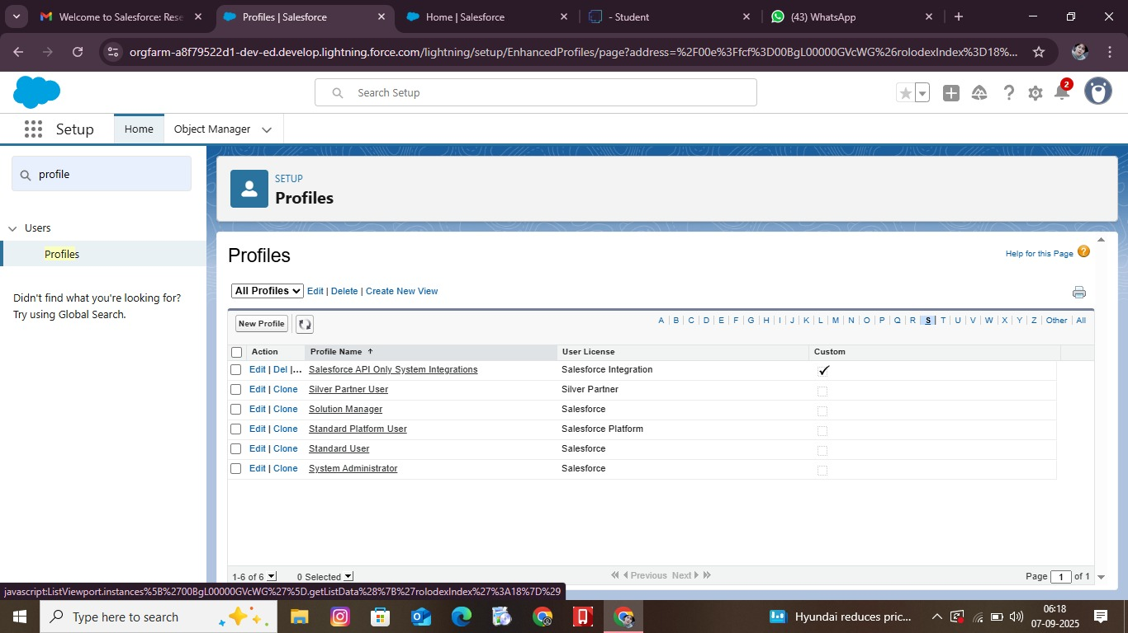

**Workers Profiles**

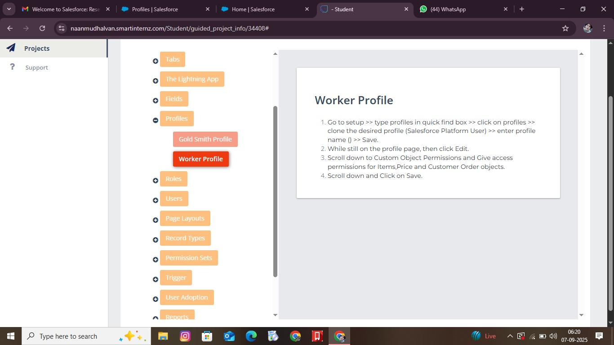

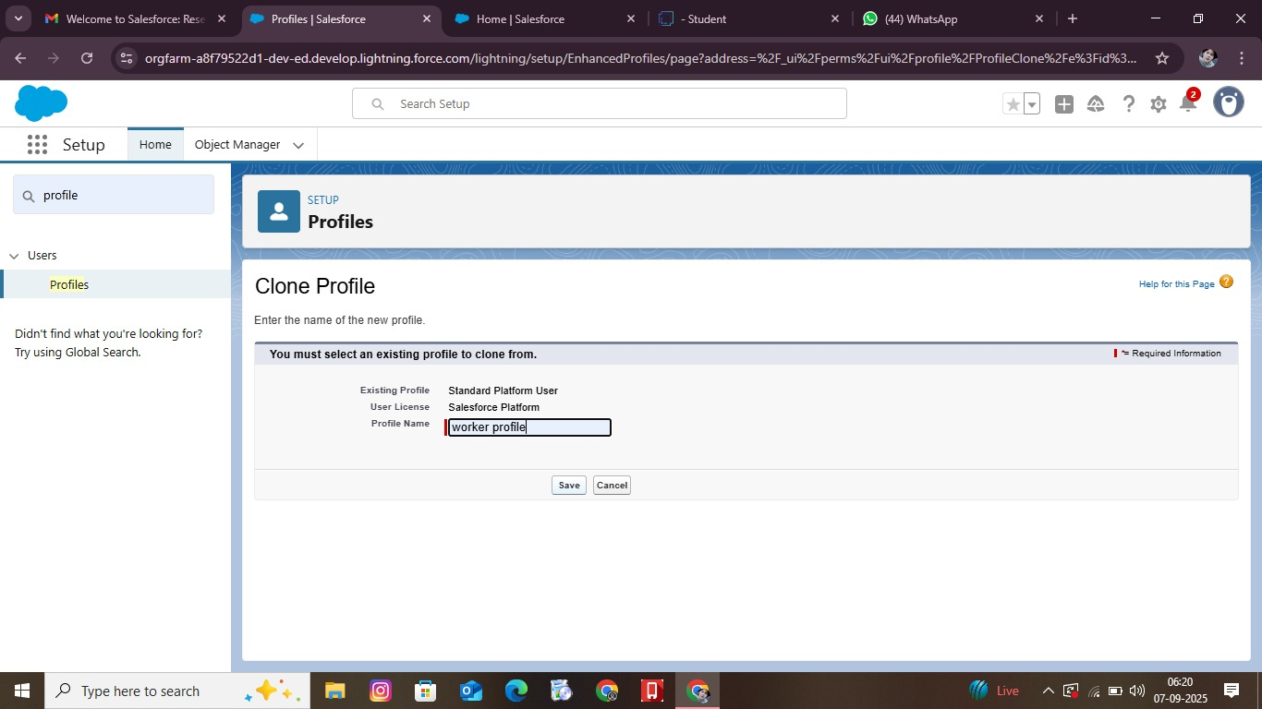

**ROLES**

**Gold Smith Roles**

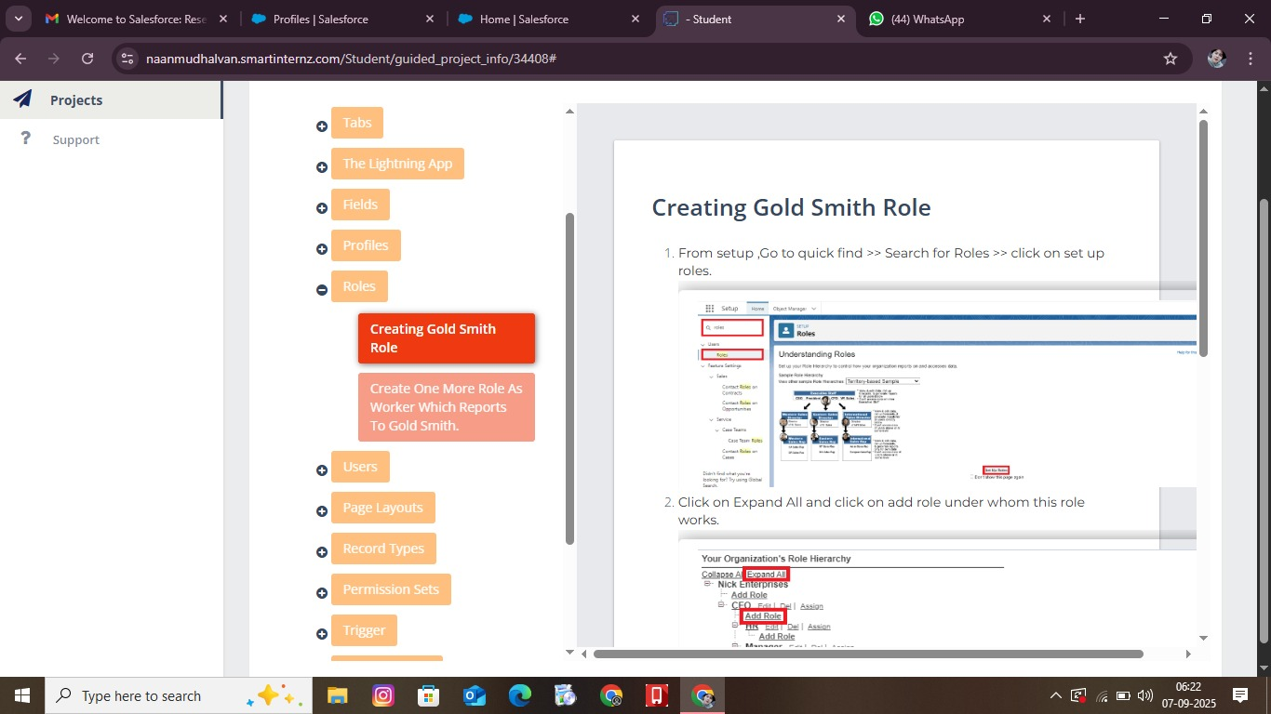

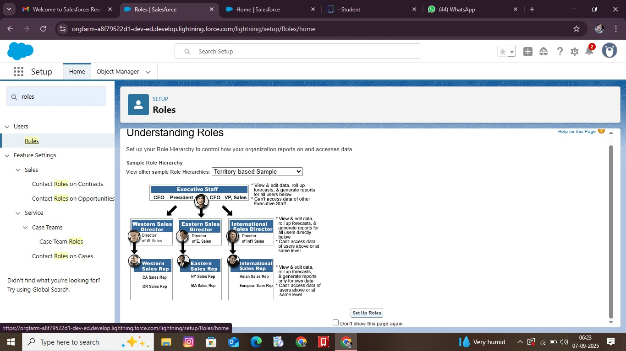

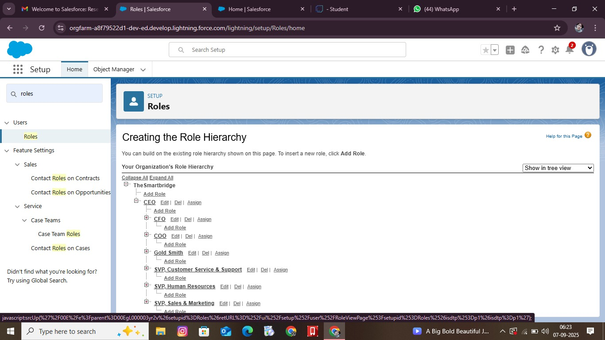

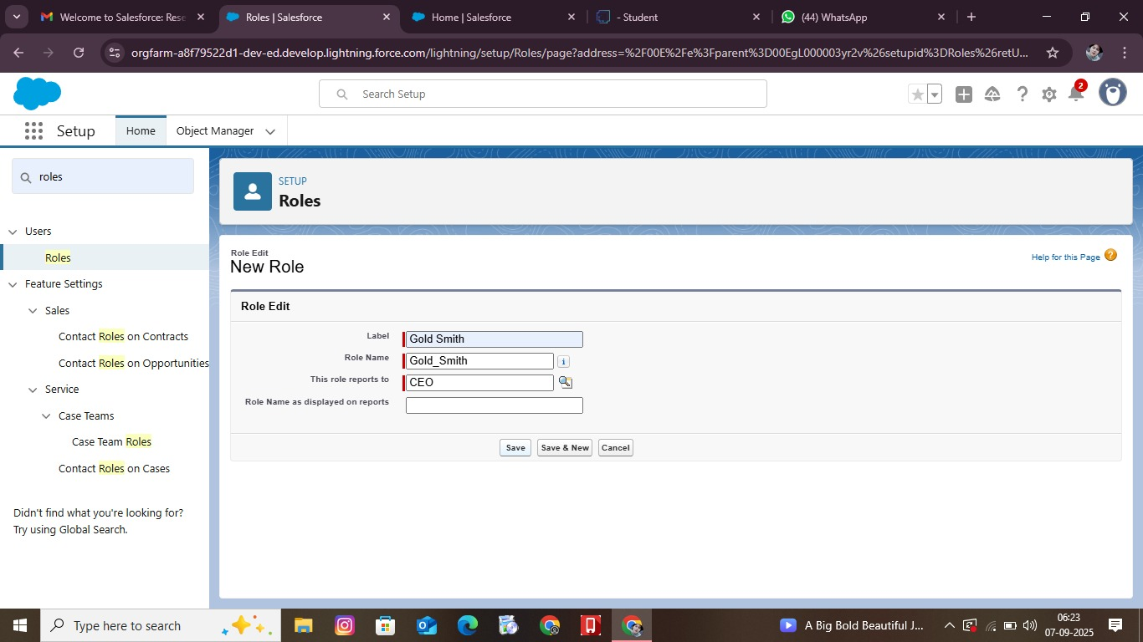

**Workers Role**

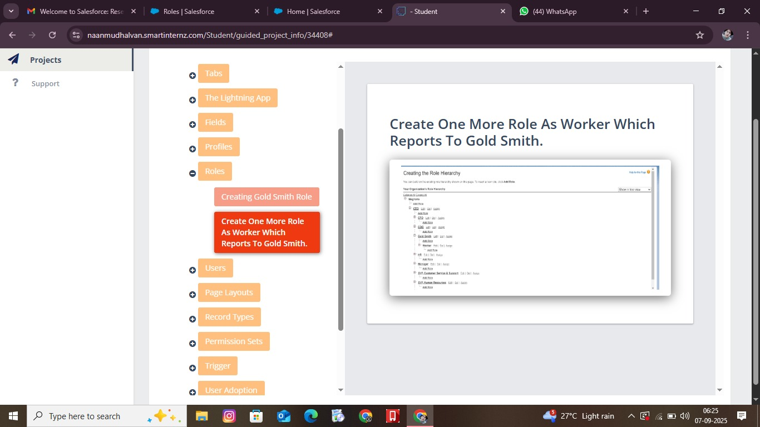

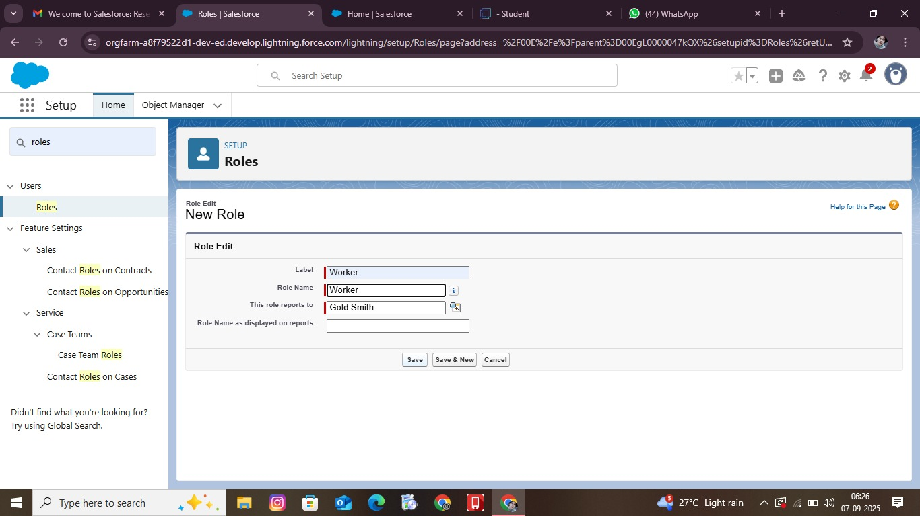

**USERS**

**Create User**

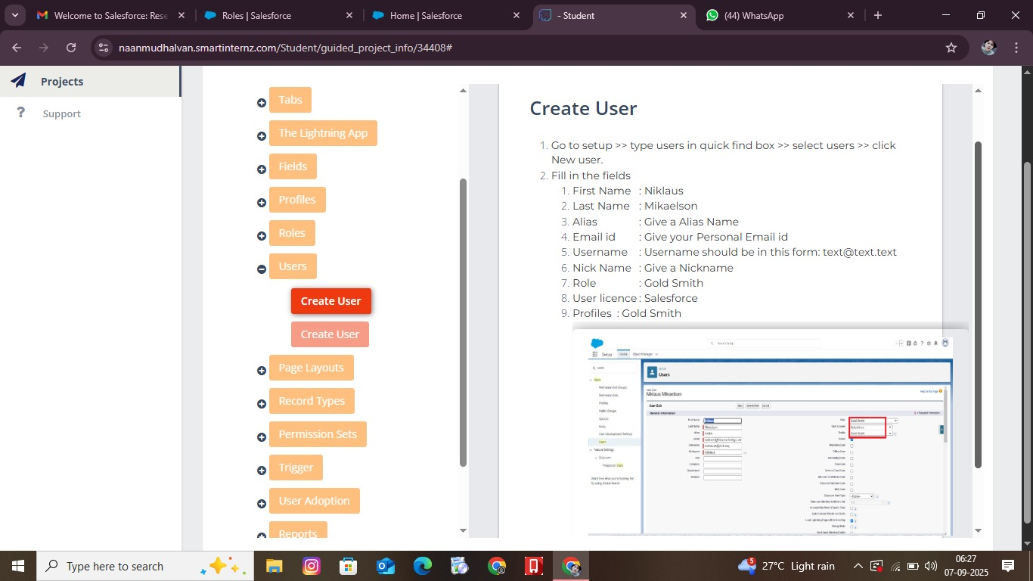

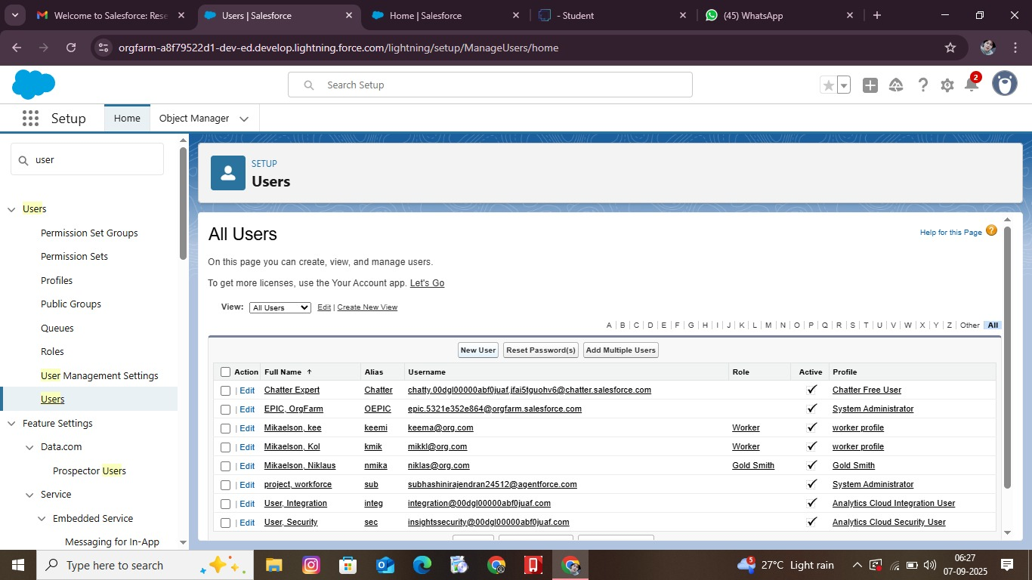

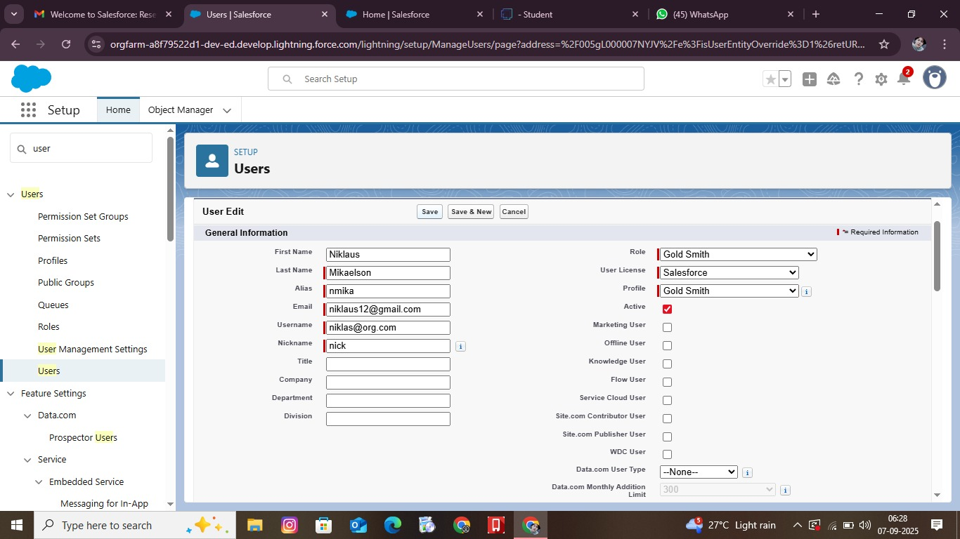

**LAYOUT**

**Gold Page Layout**

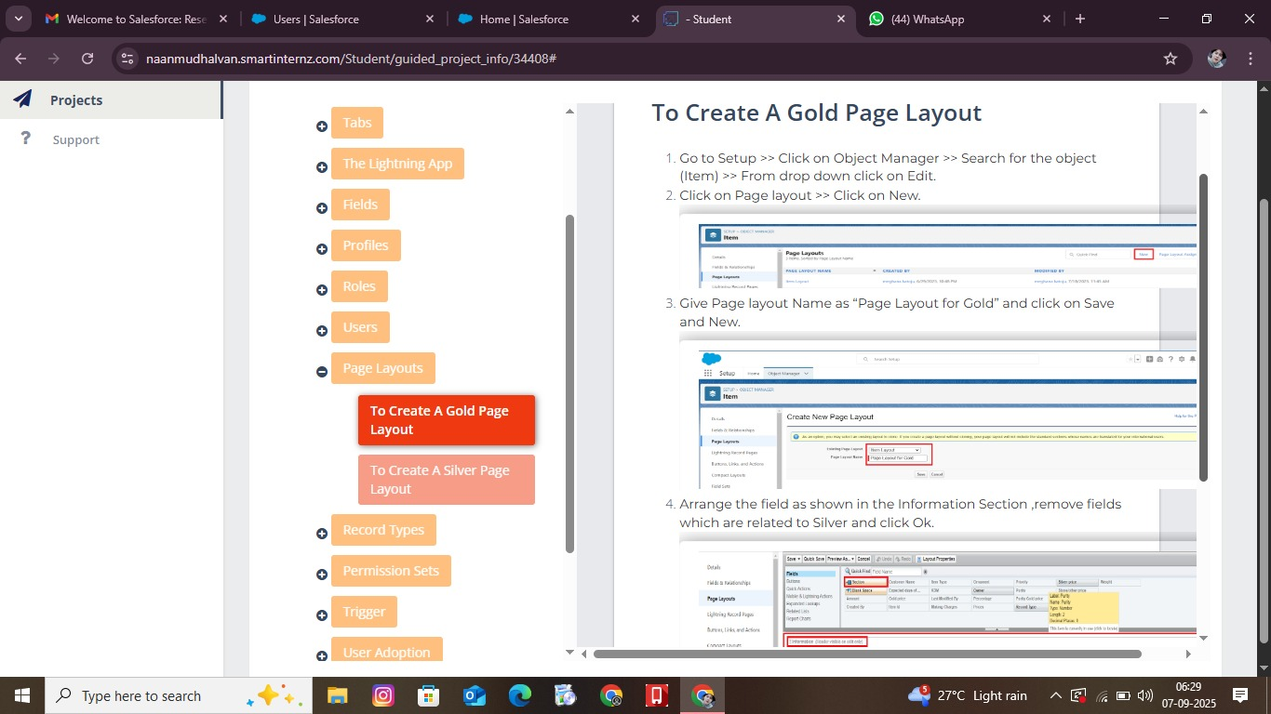

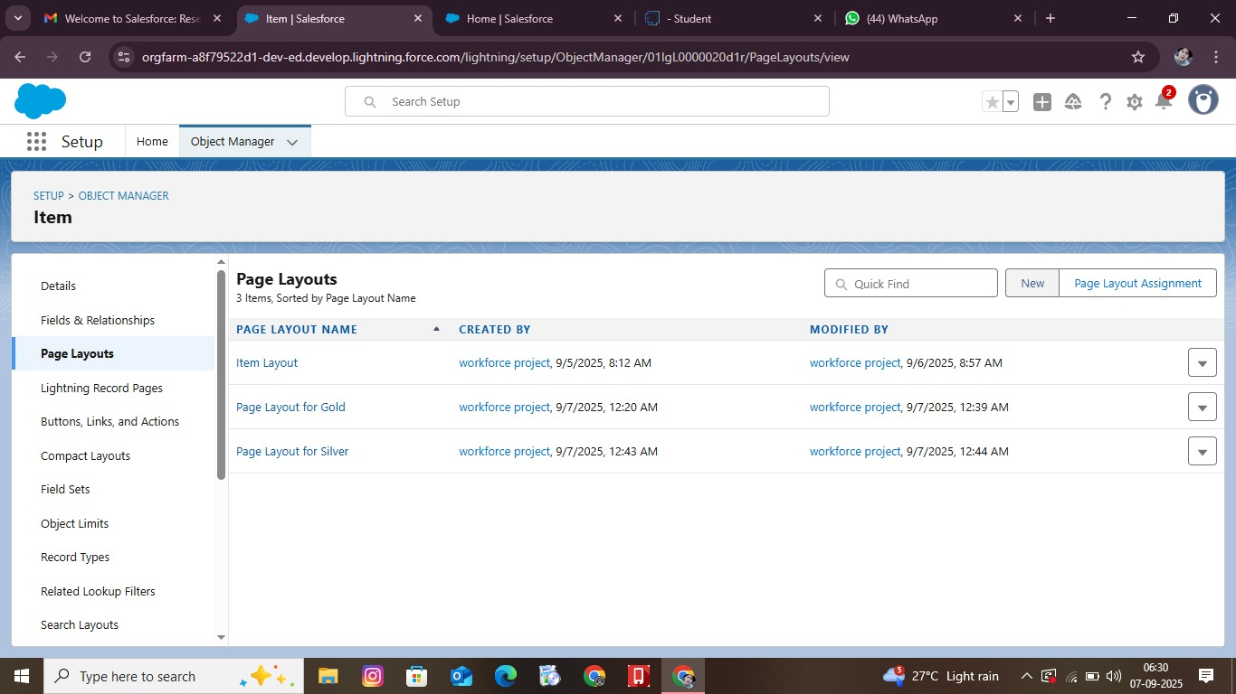

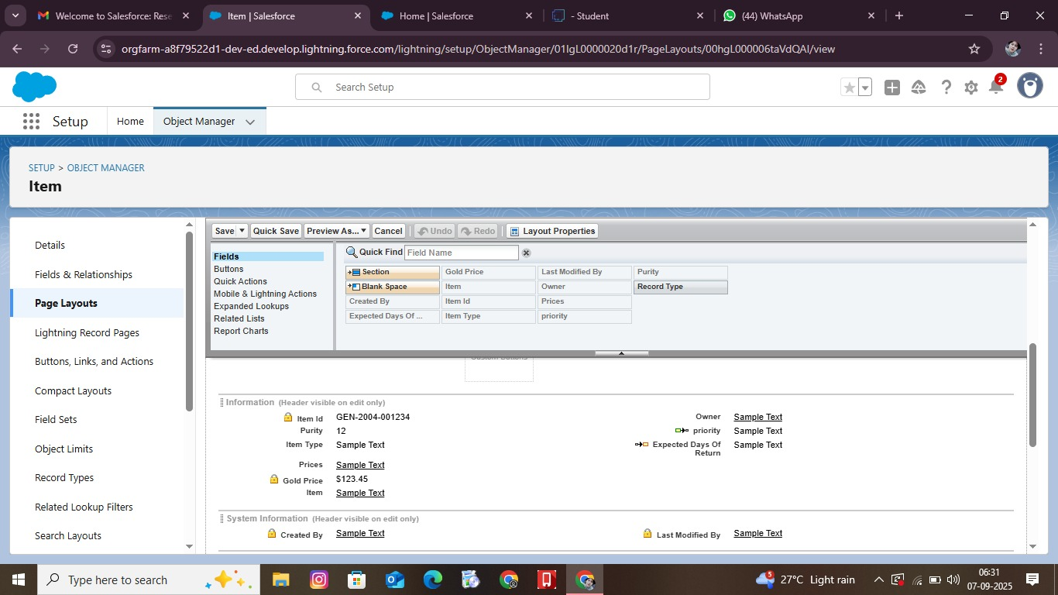

**Silver Page Layout**

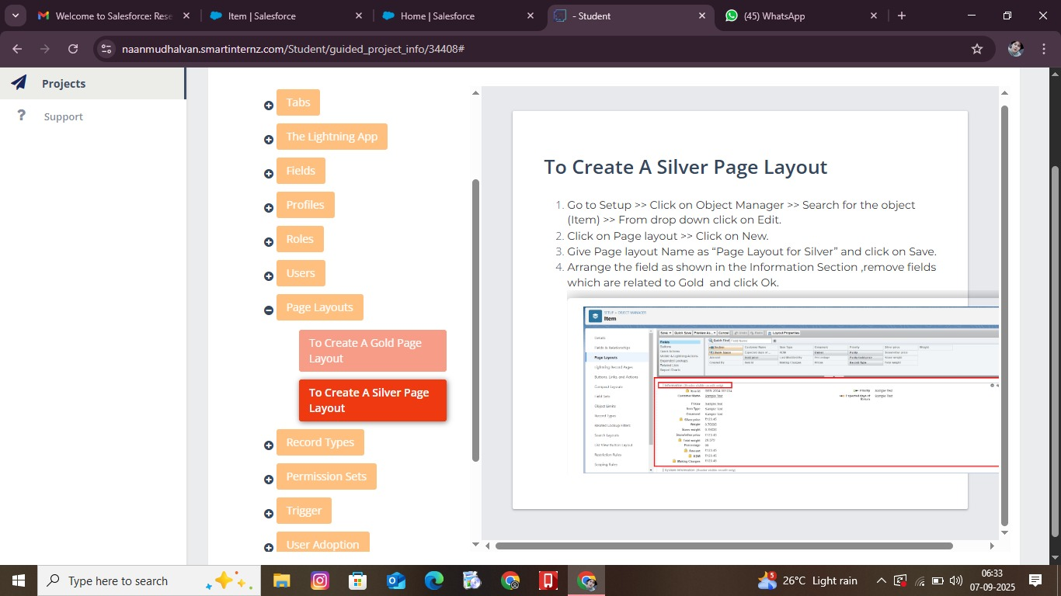

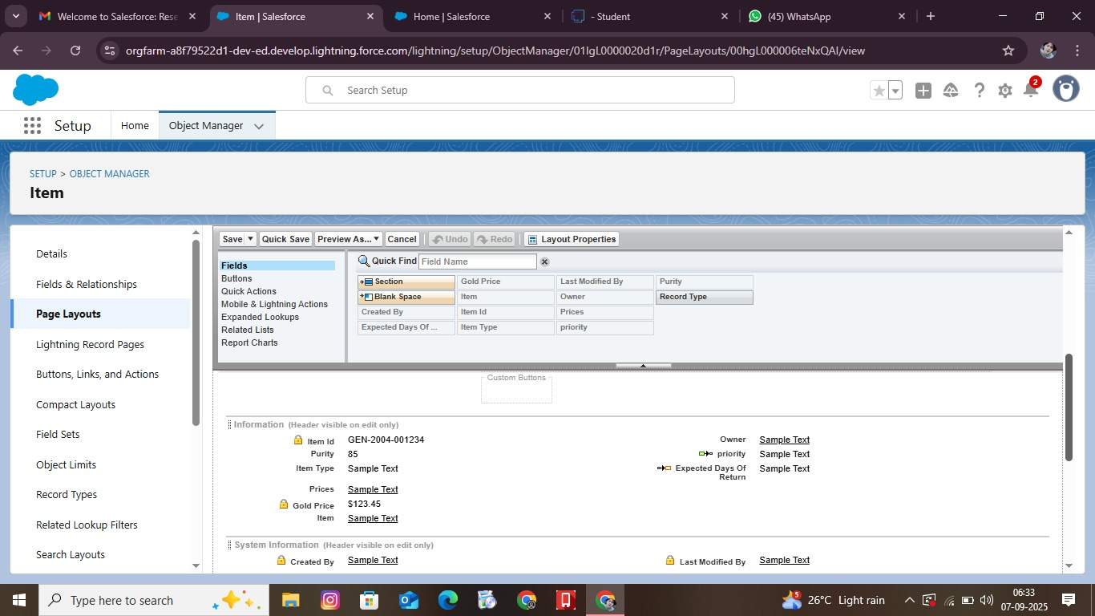

**RECORD TYPE**

**Create a Record Type**

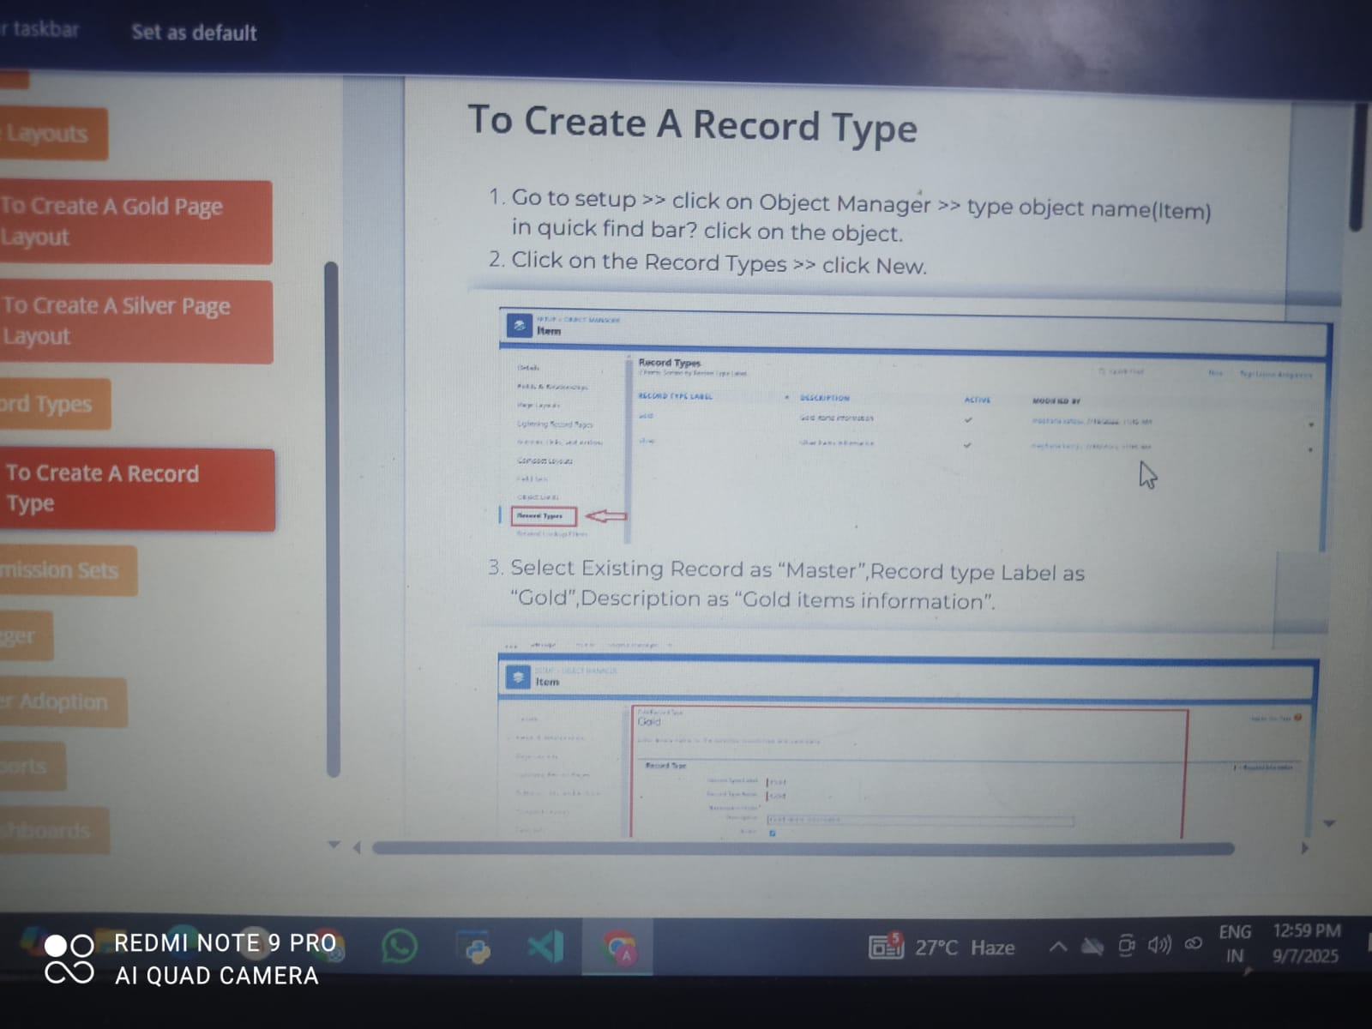

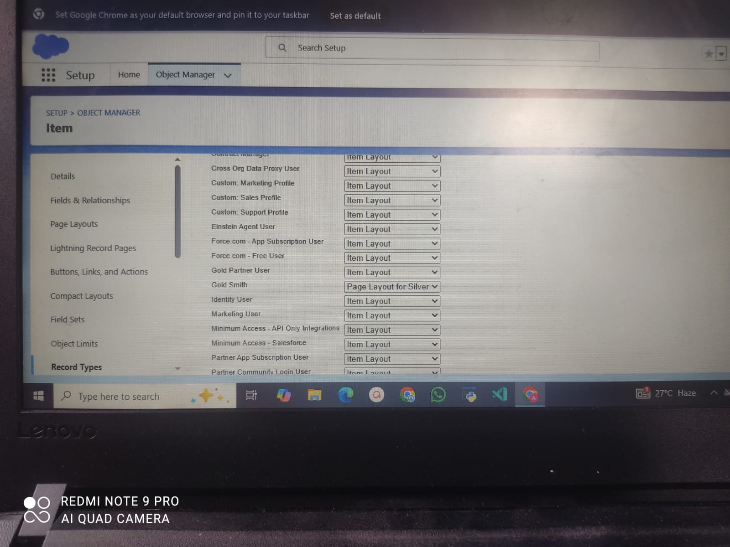

**PERMISSION SET**

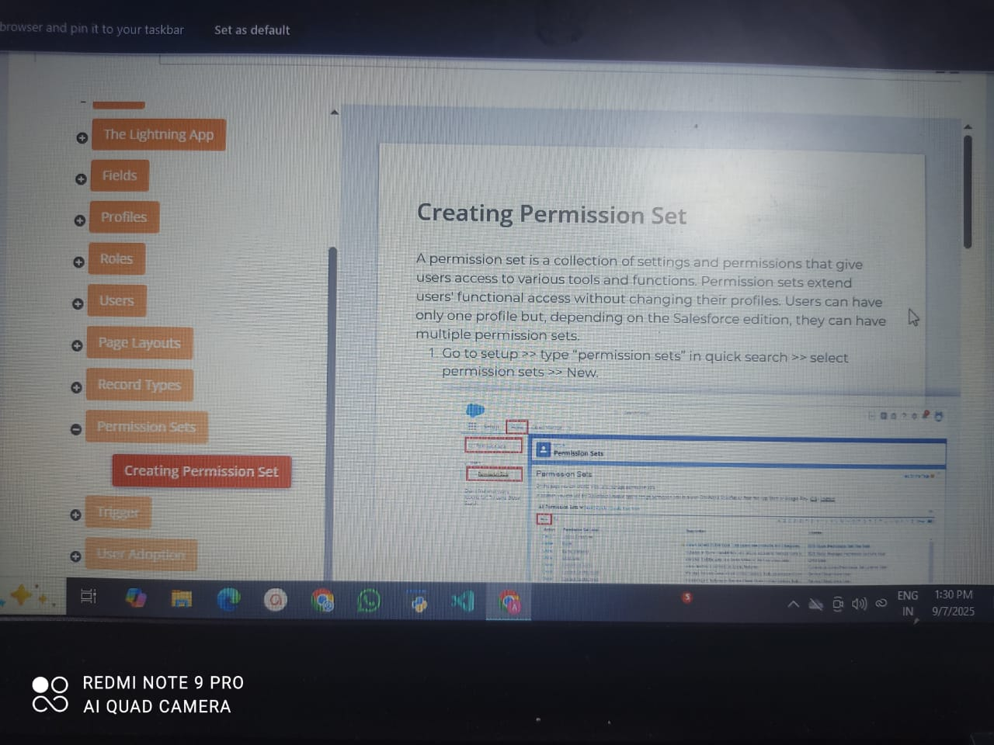

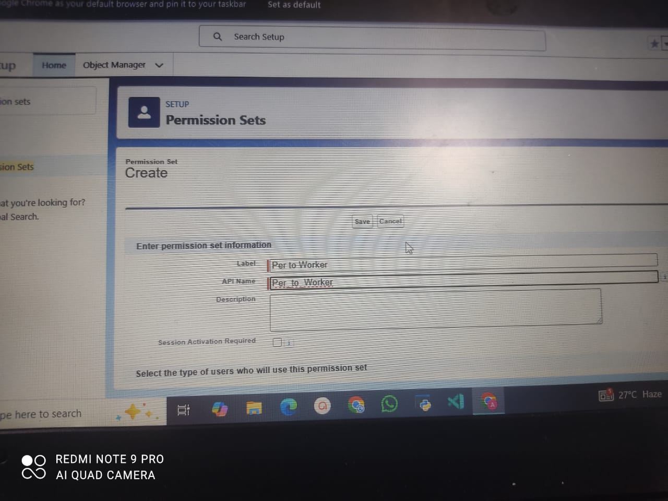

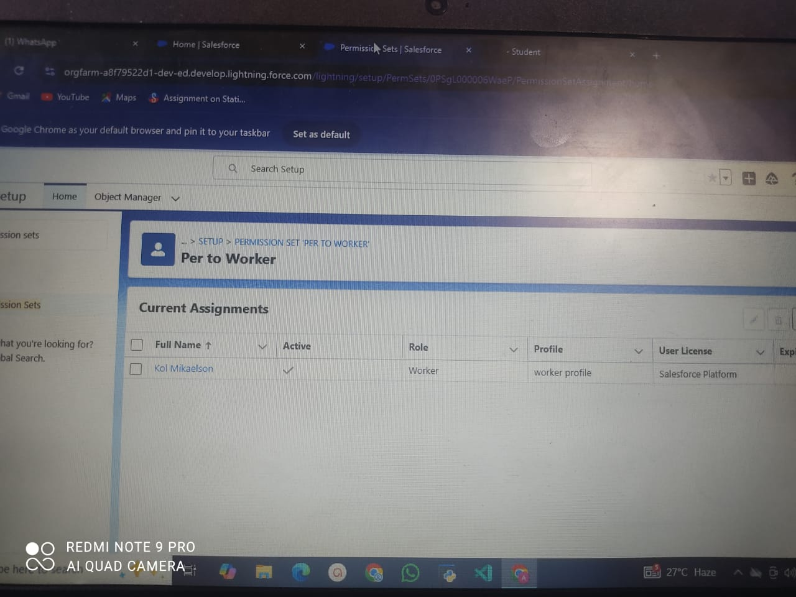

**TRIGGER**

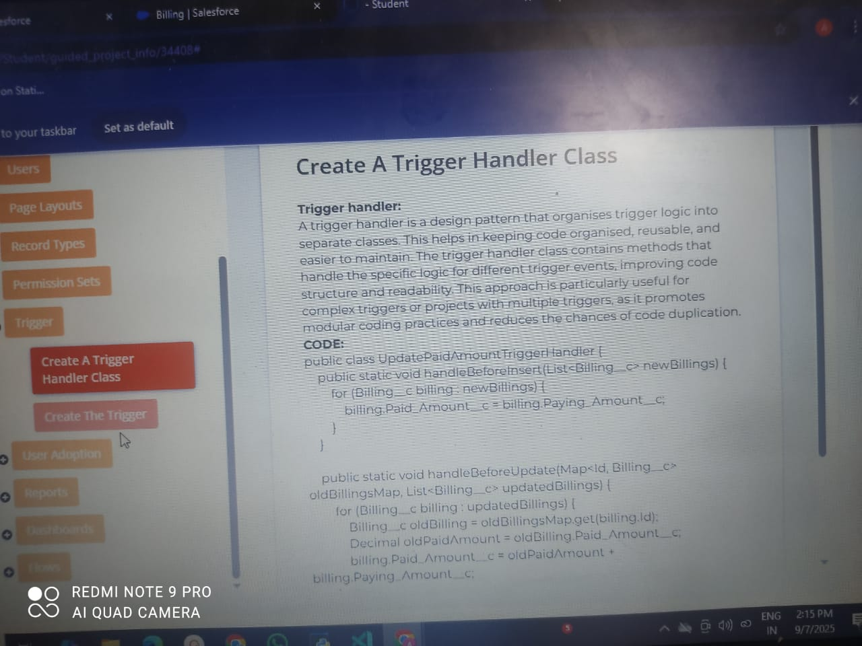

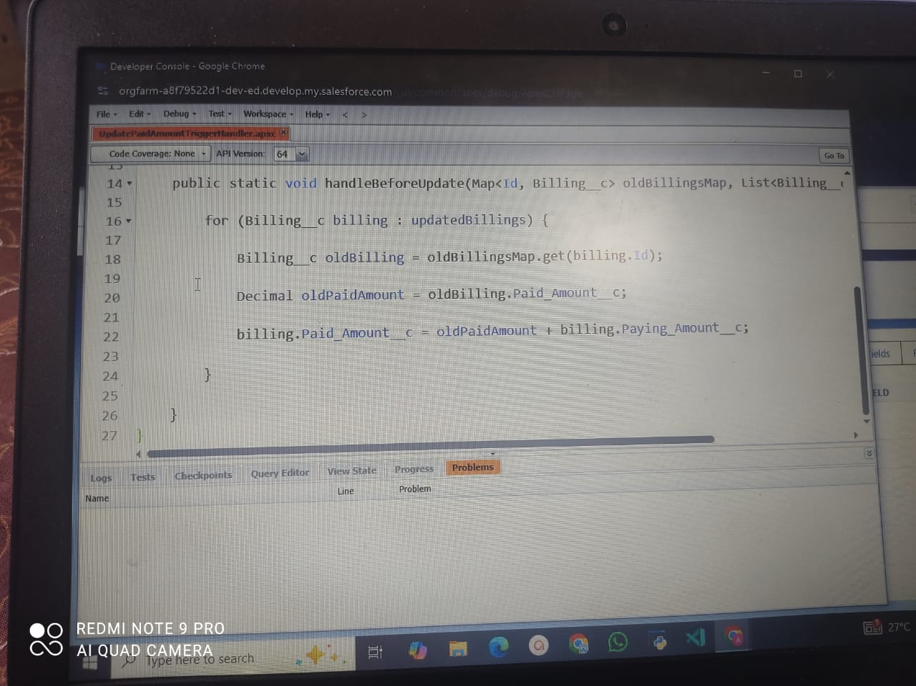

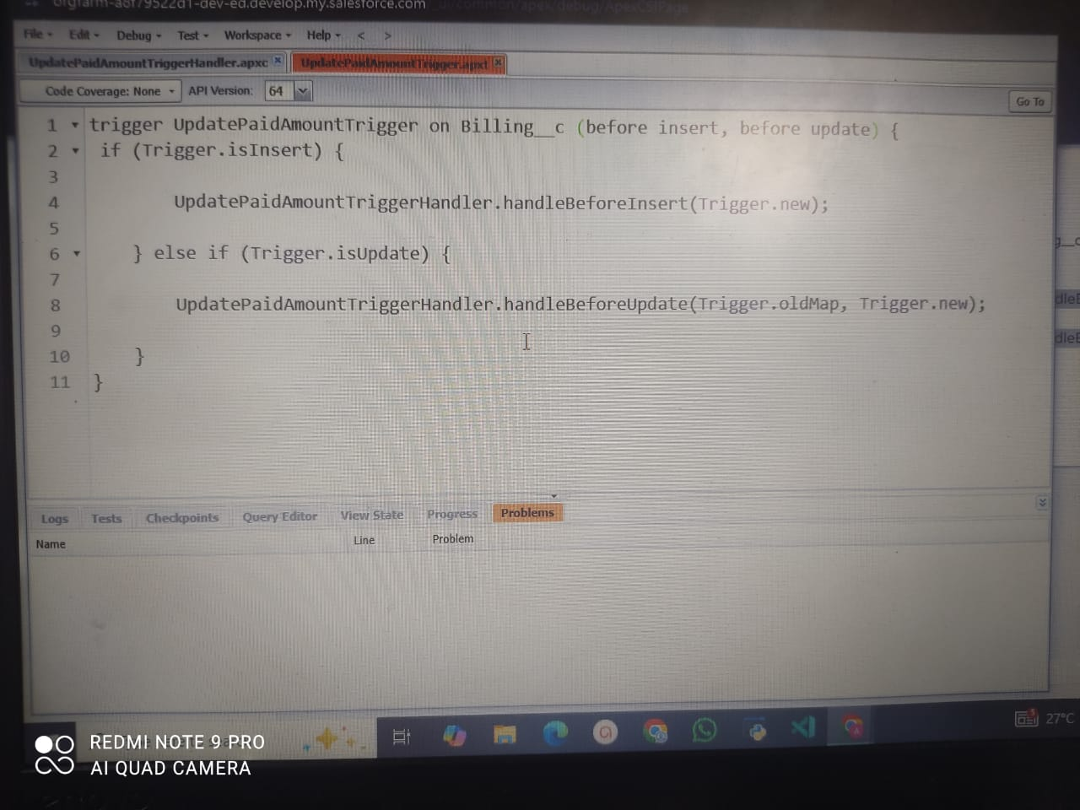

**USER ADOPTION**

**Create a Record**

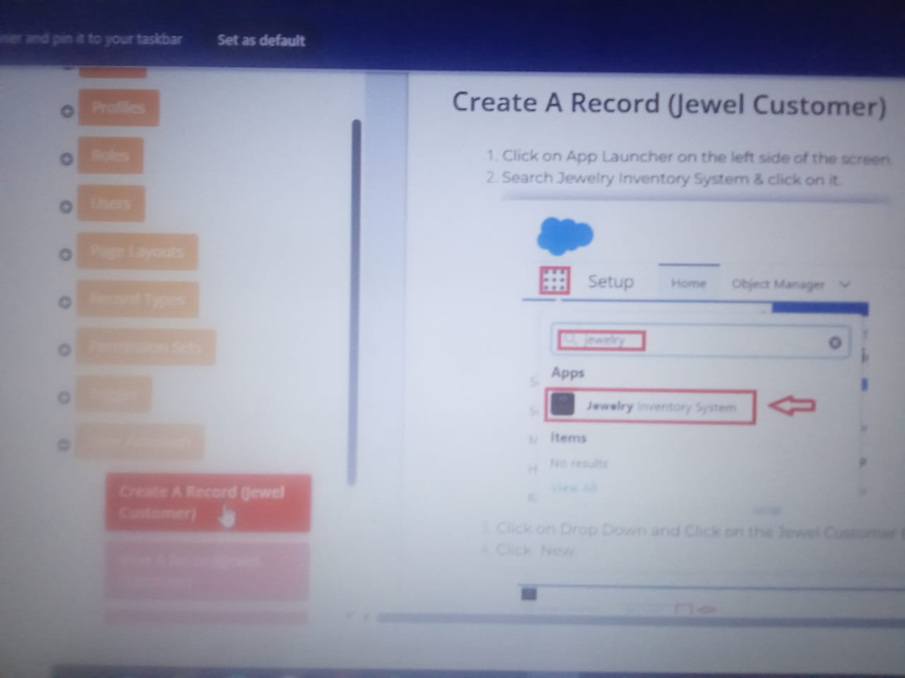

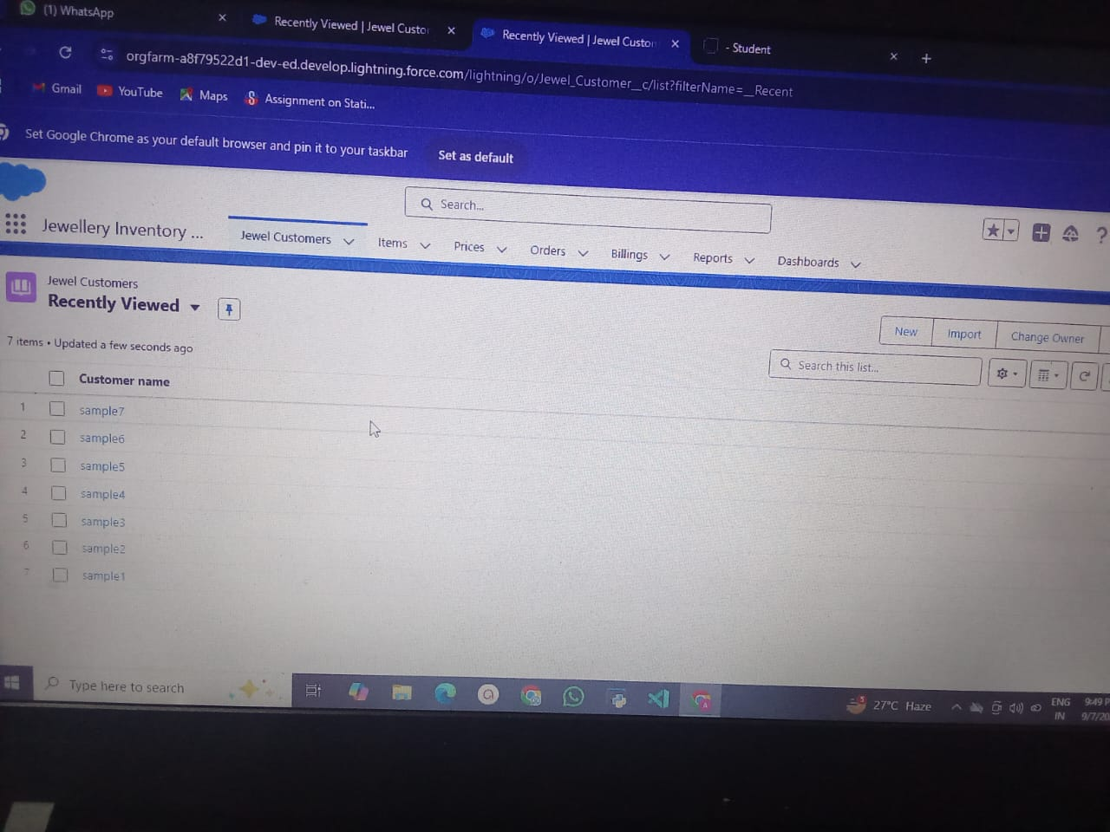

**View a Record**

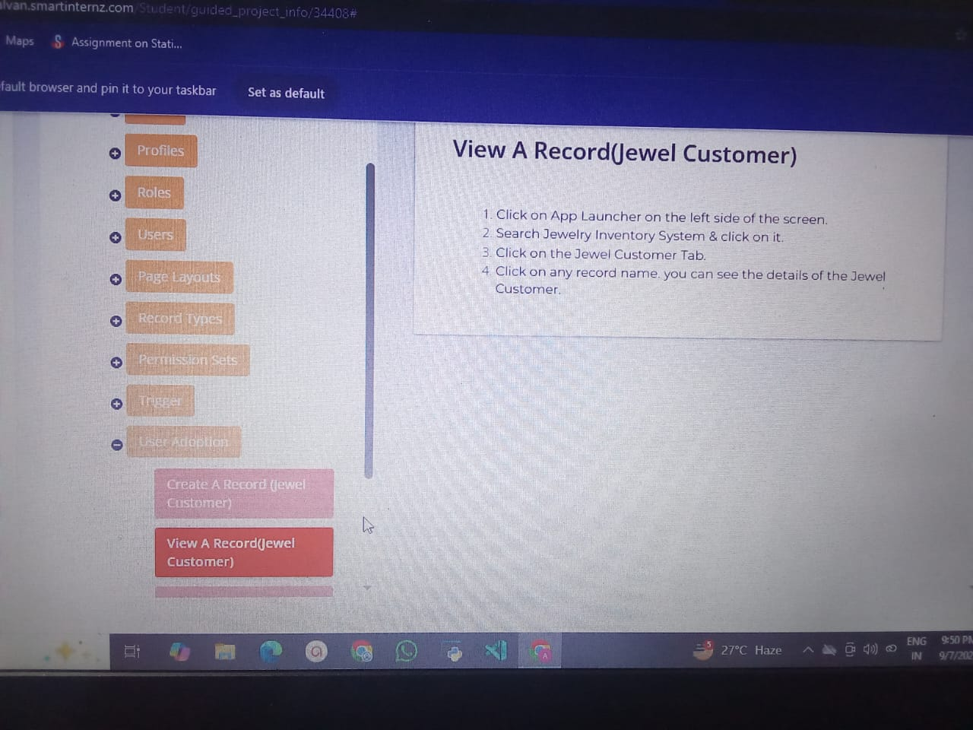

**REPORTS**

**Create a Report**

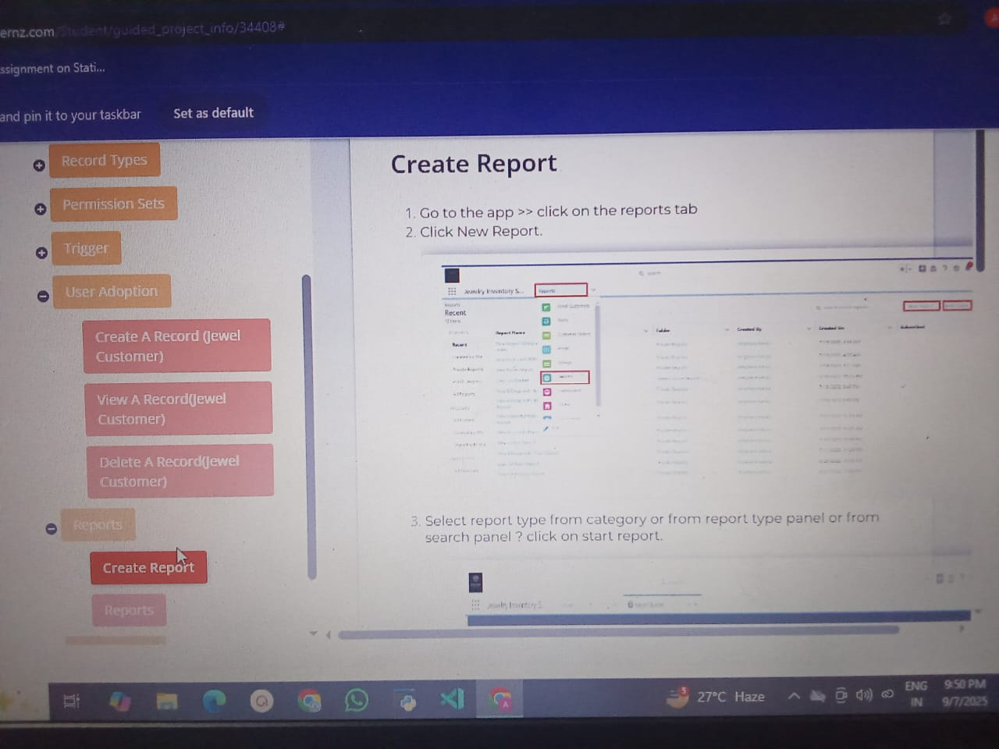

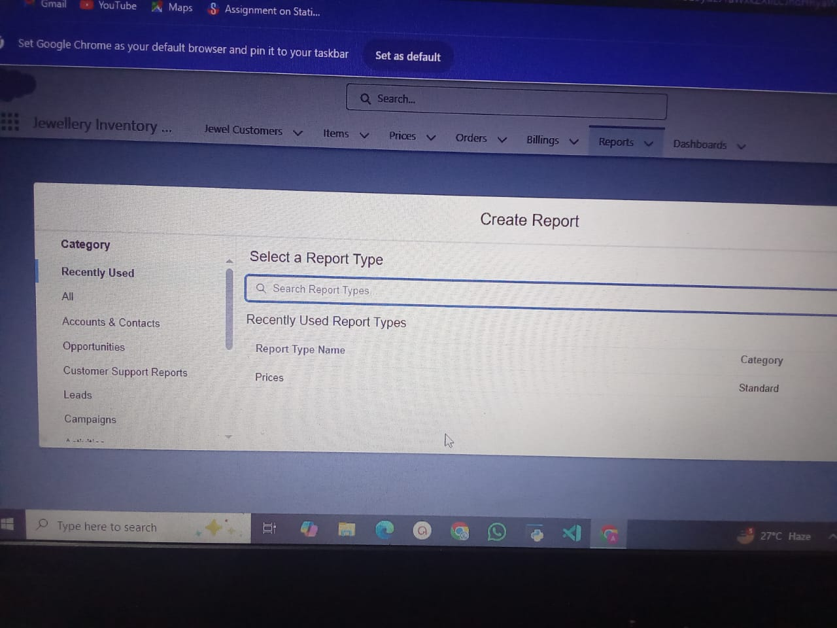

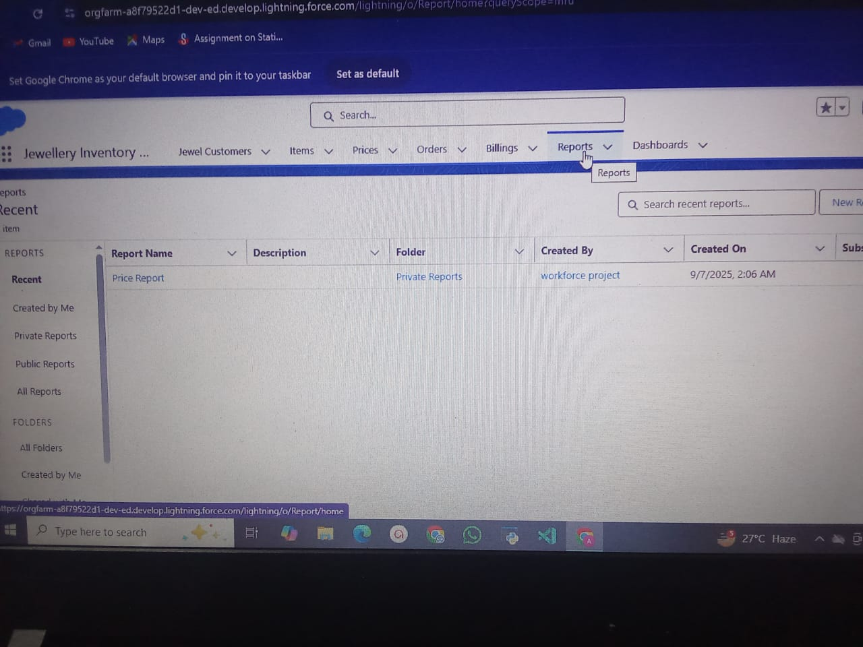

**DASHBOARDS**

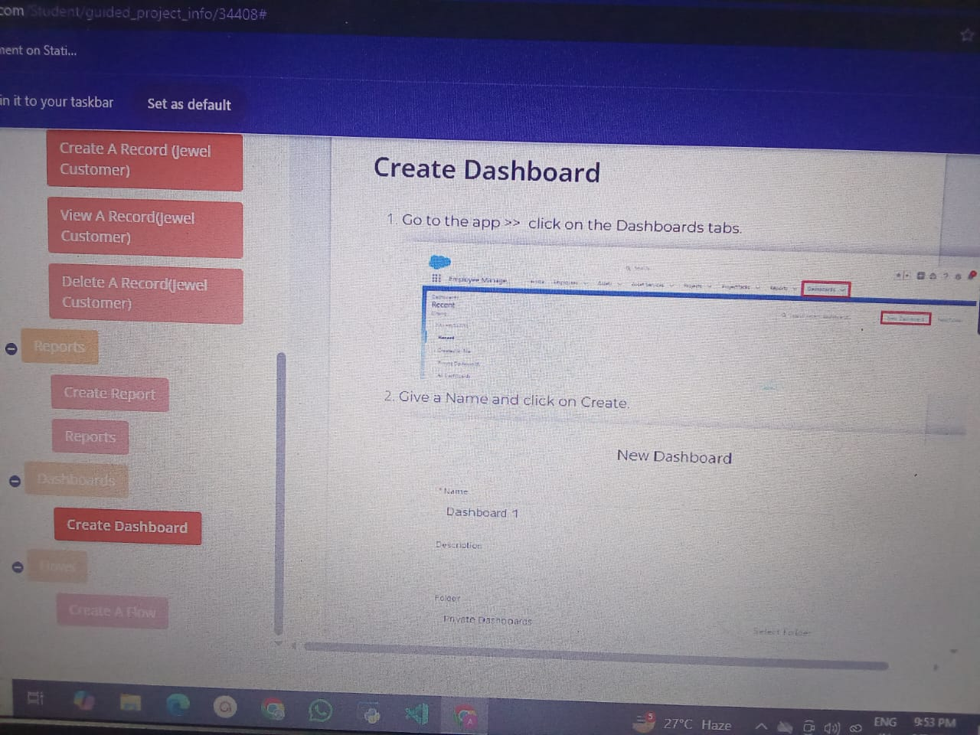

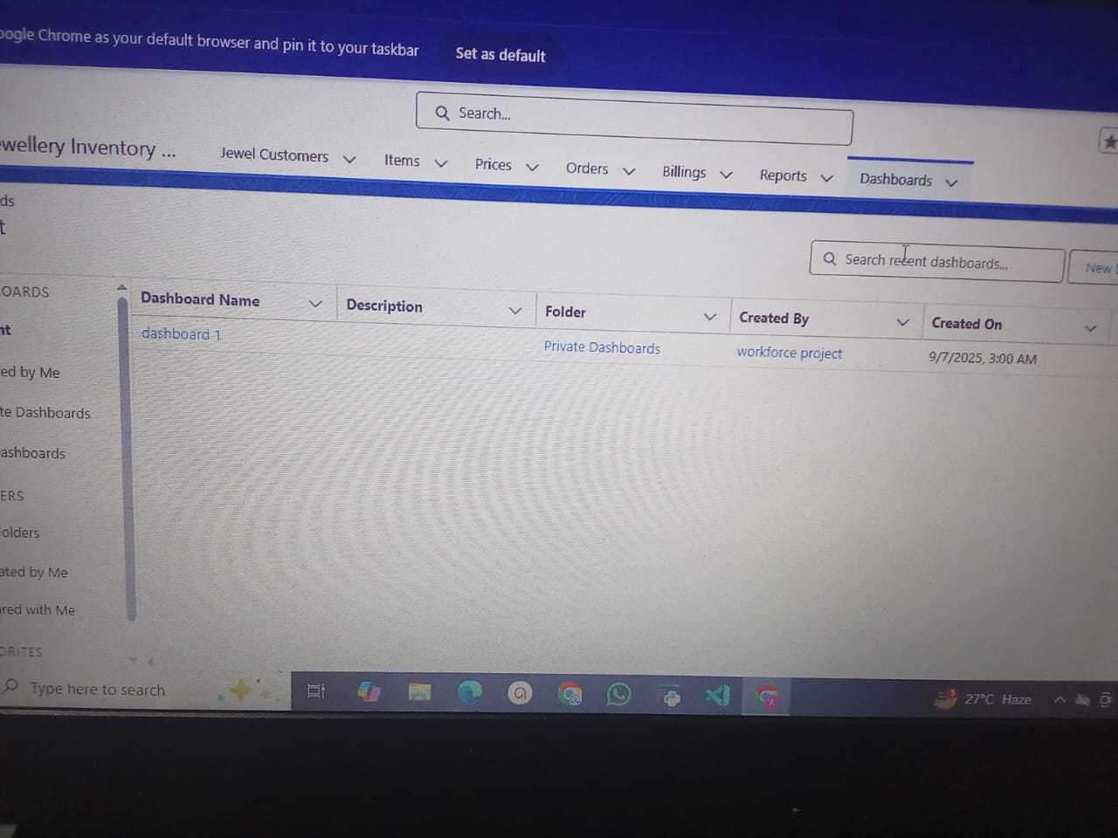

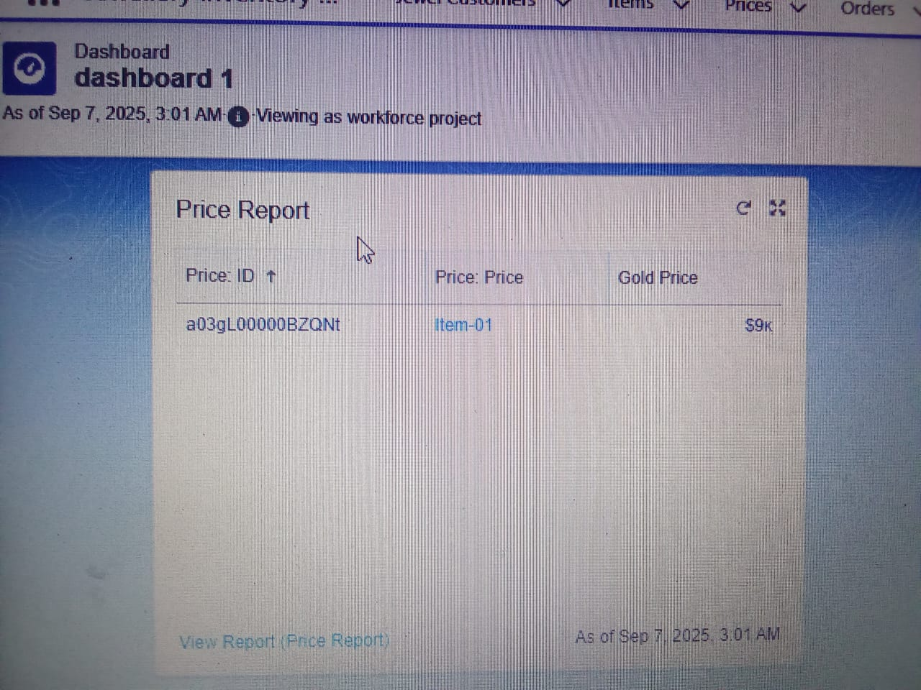

**FLOWS**

